BLOOD DONOR & CAMP MANAGEMENT
A PROJECT REPORT
Submitted by
SAHANA SHREE VS
(241501173)
in partial fulfilment of the End Semester Examination for the course
CB23F35
LOW-CODE APPLICATION DEVELOPMENT USING ZOHO CREATOR
in
BACHELOR OF TECHNOLOGY
Artificial Intelligence and Machine Learning

RAJALAKSHMI ENGINEERING COLLEGE
(An Autonomous Institution, Affiliated to Anna University, Chennai)
Rajalakshmi Nagar, Thandalam, Tamil Nadu – 602 105
OCT-2026

RAJALAKSHMI ENGINEERING COLLEGE
(An Autonomous Institution, Affiliated to Anna University, Chennai)
BONAFIDE CERTIFICATE
Certified that this project report titled “Blood Donor & Camp Management” is the bonafide work of SAHANA SHREE VS (241501173), who carried out the individual project work on the Zoho Creator low-code platform for the course CB23F35 – Low-Code Application Development using Zoho Creator, during the academic year 2026–2027, Semester V under my supervision.
SIGNATURE  Dr. M. Ayyadurai  HEAD OF THE DEPARTMENT  Department of AIML  Rajalakshmi Engineering College  Thandalam – 602 105 | SIGNATURE  Mrs. Priya M  Assistant Professor  COURSE FACULTY  Department of AIML  Rajalakshmi Engineering College

Submitted for the End Semester Examination (Individual Project) held on [DD Month YYYY].
INTERNAL EXAMINER | EXTERNAL EXAMINER

DECLARATION
I, SAHANA SHREE VS (241501173), hereby declare that the project report titled “Blood Donor and Camp Management”, submitted for the End Semester Examination of the course CB23F35 – Low-Code Application Development using Zoho Creator, is a record of original work carried out by me individually. The Zoho Creator application described in this report — including its data model, forms, reports, pages, Deluge scripts, workflows and integrations — was designed and developed by me.
I further declare that this work has not been submitted, in part or in full, for the award of any other degree or course credit. Every template, sample application, AI-assisted feature (such as Zia or the AI application builder), code snippet or external resource used in this work has been duly acknowledged in the report.
Place: Chennai SIGNATURE OF THE STUDENT
Date: [DD Month YYYY] SAHANA SHREE VS
241501173

ACKNOWLEDGEMENT
I express my sincere gratitude to our Chairman Mr. S. Meganathan, Chairperson Dr. Thangam Meganathan and Vice-Chairman Mr. Abhay Meganathan S for providing the infrastructure and facilities that made this work possible.
I am grateful to our Principal, Dr. S. N. Murugesan, Rajalakshmi Engineering College, for the constant encouragement extended to students to take up industry-relevant learning.
I thank Dr. M. Ayyadurai, Head of the Department, Department of Artificial Intelligence and Machine Learning for the guidance and support provided throughout the course.
I owe my sincere thanks to my course faculty, Mrs. Priya M, Assistant Professor, for the valuable guidance, reviews and feedback that shaped this application and report.
I also acknowledge Zoho Creator Education Programme for providing access to the Zoho Creator platform and learning resources, and I thank my family and friends for their unwavering support.

SAHANA SHREE VS

ABSTRACT
Blood donation and blood bank management involve coordinating donors, donation camps, donations, blood inventory, and hospital requests. Managing these activities manually or through separate spreadsheets can cause difficulties in organising records, tracking blood availability, retrieving donor information, and processing requests. The Blood Donor & Camp Management application was developed to centralise these activities and improve the organisation of blood bank records.
The application was built using Zoho Creator, a low-code platform that simplifies application development through forms, reports, pages, and scripting. It includes five forms: Donor Registration, Blood Camp Management, Donation Management, Blood Inventory, and Blood Requests. Corresponding reports enable users to access stored records, while a dashboard displays a donor count panel, two charts, and the Blood Requests report. A Deluge validation workflow was implemented to ensure that required units are greater than zero, issued units are not negative, and issued units do not exceed the requested quantity. External integrations, automatic inventory updates, and advanced role-based access controls are not implemented in the current version.
The application was tested in Live mode by accessing its forms, reports, and dashboard. Validation was verified by submitting a blood request with more issued units than required, which the application correctly rejected. The application is available for demonstration through Zoho Creator Live mode. Although processing-time improvements were not measured, centralised records provide a more organised way to manage information. Future enhancements may include automatic inventory updates, notifications, role-based permissions, and external service integrations.

Keywords: Low-Code Development; Zoho Creator; Deluge Scripting; Blood Donor Management; Blood Inventory; Workflow Validation.

PROJECT AT A GLANCE
Attribute | Details
Project Title | Blood Donor & Camp Management
Application Domain | Healthcare - Blood Bank Management
Student Name & Register No. | Sahana Shree VS - 241501173
Zoho Creator Edition | Zoho Creator 6 (C6)
Application Name (Link Name) | blood-donor-camp-management
Published / Live URL | https://creatorapp.zoho.in/sahanashree.vs.2024.aiml1/blood-donor-camp-management
Demo Credentials (per role) | Not configured separately
Number of Forms / Subforms | 5/0
Number of Reports (by type) | List: 5; Kanban: 0; Calendar: 0; Pivot/Chart reports: 0; Others: 0
Number of Pages / Dashboards | 1 dashboard page
Number of Workflows | Form validation: 1; Schedule: 0; Approval: 0; Blueprint: 0; Batch: 0
Deluge Functions / Custom Actions | 1 form validation script
Integrations | None implemented
Roles & Profiles Defined | Default application access; custom roles and profiles not configured
Environments Used | Zoho Creator development and Live-mode testing
Date of Production Deployment | Not deployed to production

TABLE OF CONTENTS
Formatting Standards (Anna University Convention) 1
Working with the Template 1
ABSTRACT iv
PROJECT AT A GLANCE v
LIST OF TABLES ix
LIST OF FIGURES x
LIST OF ABBREVIATIONS xi
INTRODUCTION 1
1.1 Background 1
1.2 Problem Statement 1
1.3 Objectives 1
1.4 Scope of the Project 1
1.5 Justification for a Low-Code Approach 2
1.6 Organisation of the Report 2
LITERATURE SURVEY AND SYSTEM STUDY 3
2.1 Study of the Existing System 3
2.2 Limitations of the Existing System 3
2.3 Low-Code versus Traditional Development 3
2.4 Literature Survey 4
2.5 Emerging Trends in Low-Code Development 4
2.6 Proposed System 4
REQUIREMENT ANALYSIS 5
3.1 Stakeholders and User Roles 5
3.2 Functional Requirements 5
3.3 Non-Functional Requirements 5
3.4 Hardware and Software Requirements 6
3.5 Use Case Model 6
SYSTEM DESIGN 8
4.1 System Architecture 8
4.2 Data Model 8
4.3 Form Design 9
4.4 Process and Workflow Design 9
4.5 User Interface and Navigation Design 10
4.6 Access Control Design 10
IMPLEMENTATION 11
5.1 Application Setup 11
5.2 Forms and Data Capture 11
5.3 Reports 12
5.4 Pages and Dashboards 13
5.5 Deluge Scripting 13
5.6 Workflows and Automation 14
5.7 Integrations 15
5.8 User Management and Role-Based Access 16
5.9 AI and Analytics Features 16
5.10 Pro-Code Extension 17
5.11 Mobile and Portal Access 17
TESTING AND DEBUGGING 18
6.1 Testing Strategy 18
6.2 Test Cases 18
6.3 Debugging Deluge Scripts 18
6.4 Defect Log 19
6.5 User Acceptance Testing 19
DEPLOYMENT, SECURITY AND GOVERNANCE 20
7.1 Environments and Deployment Strategy 20
7.2 Performance Optimisation 20
7.3 Security Features 21
7.4 Governance and Administration 21
RESULTS AND DISCUSSION 22
8.1 Application Output 22
8.2 Achievement of Objectives 23
8.3 Comparison with the Existing System 23
8.4 Limitations of the Low-Code Approach 23
8.5 Reflection on the No-Code → Low-Code → Pro-Code Spectrum 23
CONCLUSION AND FUTURE ENHANCEMENTS 24
9.1 Conclusion 24
9.2 Future Enhancements 24
9.3 Learning Outcomes and Career Relevance 24
REFERENCES 25
APPENDIX A – ZOHO CREATOR FEATURE COVERAGE CHECKLIST 26
APPENDIX B – COURSE OUTCOME MAPPING 28
APPENDIX C – COMPLETE DELUGE SOURCE CODE 29
APPENDIX D – USER MANUAL 30
D.1 Accessing the Application 30
D.2 Instructions for [Role 1] 30
D.3 Instructions for [Role 2] 30
APPENDIX E – EVALUATION RUBRIC 31
APPENDIX F – VIVA-VOCE RECORD SHEET 33

LIST OF TABLES
Table 2.1: Comparison of Low-Code and Traditional Development for the Proposed Application 3
Table 2.2: Summary of Literature Survey 4
Table 3.1: Stakeholders and User Roles 5
Table 3.2: Functional Requirements 5
Table 3.3: Non-Functional Requirements 5
Table 3.4: Hardware and Software Requirements 6
Table 3.5: Use Case Description – [Use Case Name] 6
Table 4.1: Entities and Relationships 9
Table 4.2: Field Specification – [Form Name] Form 9
Table 4.3: Role–Permission Matrix 10
Table 5.1: Reports Implemented 12
Table 5.2: Deluge Scripts Implemented 13
Table 5.3: Workflows Implemented 14
Table 5.4: Integrations Implemented 15
Table 6.1: Test Cases 18
Table 6.2: Defect Log 19
Table 6.3: User Acceptance Feedback 19
Table 7.1: Deployment Checklist 20
Table 7.2: Performance Optimisation Results 20
Table 7.3: Security Controls Implemented 21
Table 8.1: Mapping of Objectives to Outcomes 23
Table 8.2: Existing System versus Proposed Application 23
Table A.1: Feature Coverage Checklist 26
Table B.1: Mapping of Course Outcomes to Report Chapters 28
Table E.1: Evaluation Rubric for the Individual Project 31
Table E.2: Performance Level Descriptors 32
Table F.1: Viva-Voce Questions and Responses 33
Table F.2: Marks Summary 33

LIST OF FIGURES
Figure 2.1: As-Is Process Flow of Blood Donor and Camp Management 3
Figure 3.1: Use Case Diagram of the Blood Donor & Camp Management Application 6
Figure 4.1: System Architecture of the Blood Donor & Camp Management Application 8
Figure 4.2: Entity–Relationship Diagram of the Application 8
Figure 4.3: Workflow / Process Flow for Blood Request Validation 10
Figure 4.4: Navigation Structure and Wireframe of Dashboard Page 10
Figure 5.1: Application Home and Navigation Sections 11
Figure 5.2: Donor Registration Form in the Form Builder 11
Figure 5.3: Donor Registration Form in Live Mode 12
Figure 5.4: Blood Requests Report 12
Figure 5.5: Blood Donor & Camp Management Dashboard Page 13
Figure 5.6: Blood Request Validation Workflow Configuration 15
Figure 5.7: Zoho Creator Connection Setup and API Response Output 16
Figure 5.8: Roles and Permission Profiles Configuration 16
Figure 5.9: Dashboard Charts and Data Visualization 17
Figure 5.10: Blood Donor & Camp Management Application in Live Mode 17
Figure 6.1: Deluge Validation Script and Test Output 19
Figure 7.1: Zoho Creator Live Mode and Application Access 20
Figure 7.2: Application Workflow and Administration Settings 21
Figure 8.1: Scenario Step 1 - Successful Donor Registration 22
Figure 8.2: Scenario Step 2 - Blood Request Validation 22
Figure 8.3: Scenario Step 3 - Dashboard and Report Verification 22

LIST OF ABBREVIATIONS
Abbreviation | Expansion
API | Application Programming Interface
CRUD | Create, Read, Update, Delete
ER | Entity–Relationship
JSON | JavaScript Object Notation
LCAP | Low-Code Application Platform
OAuth | Open Authorization
RBAC | Role-Based Access Control
REST | Representational State Transfer
SDLC | Software Development Life Cycle
SSO | Single Sign-On
UAT | User Acceptance Testing
UI | User Interface
Zia | Zoho’s AI assistant

CHAPTER 1

INTRODUCTION

Background
Blood donation is an essential part of healthcare, supporting medical procedures, emergency treatments, surgeries, and the care of patients with blood-related conditions. Blood banks and donation centres coordinate several activities, including donor registration, blood donation camp organisation, donation record maintenance, blood stock monitoring, and the processing of blood requests. These activities require accurate and organised information to ensure that records can be accessed and updated efficiently.
In a typical blood bank management process, donors provide personal and contact information during registration. Blood donation camps are organised to facilitate donation activities, and details of donations are recorded for future reference. Blood inventory records help maintain information about available blood groups and their corresponding quantities. When hospitals or other authorised requesters require blood, their requests must be recorded and reviewed against the required quantities and available stock information.
These activities involve multiple types of records that are closely related. If information is maintained manually or across separate spreadsheets, staff may find it difficult to locate records, avoid duplication, monitor changes, and obtain an overall view of the current information. Maintaining separate records for donors, camps, donations, inventory, and requests can also make routine administration more time-consuming.
The Blood Donor & Camp Management application was developed as a low-code solution using Zoho Creator to organise these activities within a single application. It provides five main forms: Donor Registration, Blood Camp Management, Donation Management, Blood Inventory, and Blood Requests. Corresponding reports allow users to view the records stored in each module. A dashboard presents a total donor count, two charts, and the Blood Requests report, providing a central view of important application information.
The application also includes a Deluge validation workflow for blood requests. The workflow checks the entered quantities to prevent invalid values, including issued units exceeding the requested quantity. The application was accessed and tested in Zoho Creator Live mode to verify its forms, reports, dashboard, and validation behaviour.
The project demonstrates how a low-code platform can be used to develop a structured application for blood donation and camp administration. Its current implementation focuses on centralised record management, organised reporting, dashboard-based visibility, and blood request validation. Automated inventory updates, external service integrations, and custom role-based access controls are not included in the current version and may be considered for future development.

Problem Statement

Blood donor and camp management involves several interconnected activities, including maintaining donor information, organising blood donation camps, recording donation details, monitoring blood inventory, and managing requests for blood units. Each activity requires accurate record keeping and convenient access to relevant information. When these activities are handled using separate registers, spreadsheets, or disconnected record-management methods, maintaining consistency and retrieving information across different activities can become difficult. Staff may need to examine multiple records to obtain a complete picture of donor details, donation activities, blood stock information, and pending or recorded blood requests. Manual data entry and updates can also introduce errors, duplication, and inconsistencies in the stored information. In addition, without suitable validation rules, incorrect blood request quantities may be entered, creating a risk of unreliable request records. The absence of a consolidated dashboard can further limit the ability to review important information quickly. Therefore, a centralised application is required to organise blood donor and camp management records, provide structured forms and reports, display key information through a dashboard, and validate blood request quantities. The proposed Blood Donor & Camp Management application addresses these administrative requirements using Zoho Creator, with Deluge scripting for request validation and a unified interface for accessing the application's records.

The major problems addressed by this project are:

Fragmented record management: Donor registration, blood camp details, donation records, inventory information, and blood requests may be maintained in separate records or files. This can make information retrieval difficult and increase the effort required to maintain an organised collection of records. A centralised application helps bring these activities together within a single environment.

Difficulty maintaining consistent information: Repeated data entry and manual record updates may result in missing, duplicated, or inconsistent information. When users refer to different records for related activities, verifying the correctness of the information can require additional effort. Structured forms help standardise the way information is entered and stored.

Limited visibility of important information: Reviewing donor information, donation activities, and blood requests may require users to navigate through several individual records. Without a consolidated view, it can be less convenient to understand the overall state of the information maintained by the application. A dashboard containing the total donor count, two charts, and the Blood Requests report provides a central point for reviewing selected information.

Risk of incorrect blood request quantities: Blood request records may contain invalid quantity values if suitable validation is not applied. For example, the number of issued units should not be negative or exceed the requested quantity, and the required quantity should be greater than zero. The implemented Deluge validation workflow checks these conditions and rejects invalid entries, helping improve the consistency of blood request records.

Difficulty accessing and reviewing records: When information is stored across multiple files or registers, users may spend additional time locating the relevant details and reviewing previous records. Providing separate reports for donor registration, camp management, donation management, blood inventory, and blood requests makes the stored information easier to access and inspect.

Limited automation of administrative checks: Manual checking of entered information can increase administrative effort and may allow errors to remain unnoticed. Implementing validation through a workflow reduces the need to rely entirely on manual quantity checks. However, the current application focuses on request validation and does not automatically update inventory after every donation or blood issue.

By addressing these problems, the project aims to provide a more organised approach to maintaining blood donation-related records. The application combines structured forms, corresponding reports, a dashboard, and a validation workflow within Zoho Creator. Its primary objective is to improve record organisation and enforce basic blood request quantity rules, while more advanced capabilities—such as automatic inventory synchronisation, notifications, external integrations, and custom role-based access controls—remain potential future enhancements.

1.3 Objectives

The main objectives of the Blood Donor & Camp Management application are:

To design and implement five structured forms for donor registration, blood camp management, donation management, blood inventory, and blood requests in Zoho Creator.

To organise application records through corresponding reports for convenient viewing and retrieval.

To implement a Deluge validation workflow that checks blood request quantities and rejects invalid entries.

To develop a dashboard displaying the total donor count, two charts, and the Blood Requests report.

To test the forms, reports, dashboard, and validation workflow in Zoho Creator Live mode and verify the application's behaviour using representative test cases.

To identify limitations in the current implementation and propose future enhancements, including automated inventory updates, notifications, and role-based access controls.

1.4 Scope of the Project

The project focuses on developing a web-accessible blood donor and camp management application using Zoho Creator. The scope includes the creation of forms, reports, a dashboard

page, and a Deluge validation workflow to support the organisation of blood donation-related records.

In-scope components:

Donor Registration: Stores donor details entered through the registration form.

Blood Camp Management: Maintains records related to blood donation camps.

Donation Management: Stores information about donation activities.

Blood Inventory: Maintains blood group and available-unit records.

Blood Requests: Records blood requests and validates the entered required and issued quantities.

Reports: Provides access to records maintained in each of the five forms.

Dashboard: Displays the total donor count, two charts, and the Blood Requests report.

Validation workflow: Uses Deluge scripting to check blood request quantities and reject invalid entries.

Testing: Verifies the application's forms, reports, dashboard, and validation behaviour through Zoho Creator Live mode.

The application is intended to demonstrate the organisation and validation of blood bank-related records. Its current scope does not include automatic synchronisation of inventory after every donation or issue, integration with external services such as Zoho CRM, custom role and permission configuration, a dedicated customer portal, or verified production deployment. These features are potential future enhancements. The application also does not replace professional medical decisions, donor eligibility assessments, blood screening, or clinical procedures.

1.5 Justification for a Low-Code Approach

Low-code development is an approach that allows applications to be created using visual development tools, configurable components, and limited amounts of programming. Zoho Creator was selected for this project because it provides a suitable environment for developing a record-management application without building every component from scratch.

Rapid application development: Zoho Creator provides form and report builders that simplify the creation of data-entry interfaces and record views. This supports the development of the five modules required for the Blood Donor & Camp Management application.

Reduced development complexity: The platform provides built-in application components that reduce the need to develop forms, record views, and dashboard elements manually using separate technologies. This makes the approach suitable for an academic project with a defined development scope.

Workflow customisation: Zoho Creator supports Deluge scripting for implementing application logic. In this project, Deluge is used to validate blood request quantities, demonstrating how low-code development can combine visual configuration with custom business rules.

Maintainability: Forms, reports, dashboard components, and workflows can be managed within the same development environment. This helps developers inspect and modify individual application components as requirements change.

Data presentation and accessibility: Reports and dashboard components provide different ways to view stored information. Zoho Creator also supports application access through its supported interfaces, making it useful for developing applications that users can access without building a separate front end from the beginning.

Development effort and cost considerations: Reusing the platform's built-in components can reduce implementation effort compared with developing an equivalent application entirely from scratch. However, actual costs and available features depend on the Zoho Creator plan, so the project does not assume that every platform capability is available free of charge.

Overall, Zoho Creator is appropriate for this project because it supports structured data entry, reporting, dashboard creation, and workflow validation within a single development environment. The platform's official documentation provides further information about its application-building and Deluge capabilities.

Reference:

Zoho Corporation, Zoho Creator Help Documentation. Available at: https://www.zoho.com/creator/help/

1.6 Organisation of the Report

This report is organised into nine chapters. Chapter 1 introduces the project background, problem statement, objectives, scope, and justification for using a low-code development approach. Chapter 2 reviews the existing system and related low-code development concepts. Chapter 3 presents the requirement analysis, including the functional and non-functional requirements of the application. Chapter 4 describes the system design, architecture, data model, workflow, and navigation structure. Chapter 5 explains the implementation of the forms, reports, dashboard, and validation workflow in Zoho Creator. Chapter 6 discusses the testing and debugging activities performed to verify the application's behaviour. Chapter 7 examines deployment considerations, performance optimisation, security, and governance, distinguishing implemented features from proposed improvements. Chapter 8 presents the testing results and discussion of the application's capabilities and limitations. Finally, Chapter 9 concludes the report and outlines possible feature enhancements.

CHAPTER 2

LITERATURE SURVEY AND SYSTEM STUDY

2.1 Study of the Existing System

Blood donor and camp management activities involve maintaining donor details, organising blood donation camps, recording donations, maintaining blood stock information, and processing blood requests. In a basic manual or spreadsheet-based system, these activities may be handled through separate registers, spreadsheets, or individual records. The exact procedure varies according to the organisation and the tools available.

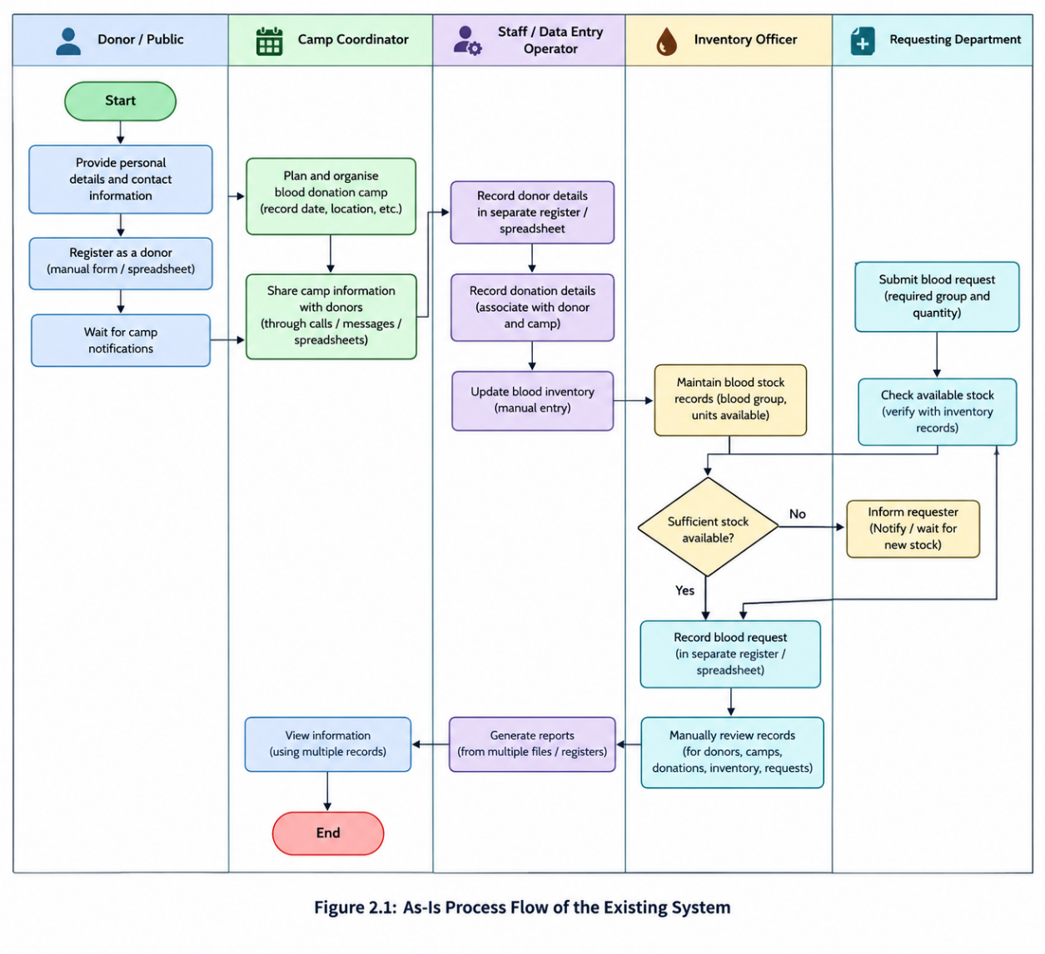
The activities are managed independently, users may need to switch between multiple records to retrieve information and check consistency. This creates a need for a centralised system that organises these activities and provides a consolidated view of important records.
Figure 2.1: As Is Process Flow of the application

2.2 Limitations of the Existing System

The typical manual or spreadsheet-based approach has the following limitations:

Fragmented information: Donor, camp, donation, inventory, and request records may be maintained separately, making information retrieval less convenient.

Record inconsistency: Repeated data entry and manual updates can result in duplicate or inconsistent information.

Limited consolidated visibility: Users may need to open multiple registers or spreadsheets to review donor details, donation activities, and blood requests.

Manual checking of quantities: Incorrect values in blood requests may not be identified consistently without validation rules.

These limitations form the basis for developing a centralised application with structured forms, reports, a dashboard, and validation rules.

2.3 Low-Code versus Traditional Development

Traditional development generally requires developers to build and connect the data layer, user interface, business logic, and hosting environment using programming languages and development frameworks. Low-code development, in contrast, provides visual builders and reusable components that reduce the amount of infrastructure and interface code that must be written manually.

For the Blood Donor & Camp Management application, Zoho Creator was selected because it provides form building, report generation, dashboard components, and Deluge scripting within one platform.

Table 2.1: Comparison of Low-Code and Traditional Development for the Proposed Application
Criterion | Traditional (Pro-Code) Development | Low-Code on Zoho Creator
Development time | 4-6 weeks | 2–3 weeks
Skills required | Programming and database skills | Visual tools and basic Deluge
Hosting & infrastructure | Requires setup | Platform-managed
Mobile application | Requires responsive/mobile development | Supported mobile access
Security & access control | Custom configuration required | Built-in controls; configuration needed
Maintenance & change | Code changes and testing | Visual editing and workflow updates
Customisation limits | Highly flexible | Platform dependent
Cost | Development and hosting costs | Plan dependent subscription costs

2.4 Literature Survey

The following literature and documentation were reviewed to understand low-code development, application usability, workflow capabilities, and the requirements of blood donation services.
Table 2.2: Summary of Literature Survey
S.No. | Author / Source & Year | Title / Product | Key Findings | Relevance to Project
1 | Bucaioni et al. (2022) | Modelling in Low-Code Development | Reviews modelling in low-code platforms. | Supports structured application design.
2 | Pinho et al. (2023) | Usability in Low-Code Platforms | Reviews usability of low-code tools. | Supports simple forms and dashboards.
3 | Zoho Corporation (n.d.) | Zoho Creator Help | Explains forms, reports, and applications. | Guides module development.
4 | Zoho Corporation (n.d.) | Understanding Workflows | Describes event-driven workflow automation. | Supports Deluge validation.
5 | World Health Organization (2026) | Blood Safety and Availability | Highlights safe and organised blood services. | Establishes the healthcare context.

The reviewed sources provide complementary perspectives. Research on low-code development supports the use of visual modelling and usability-oriented design. Zoho Creator documentation explains the platform features used to build and validate the application. WHO guidance establishes the importance of organised blood services and safe blood supply management.
The present project applies these concepts to a small record-management application. It focuses on administrative record organisation and quantity validation; it does not implement clinical screening, donor eligibility assessment, blood compatibility testing, or a complete blood bank information system.
References for the Literature Survey
- Bucaioni, A., Cicchetti, A., and Ciccozzi, F. (2022). “Modelling in low-code development: a multi-vocal systematic review.” Software and Systems Modeling, 21, 1959–1981. https://doi.org/10.1007/s10270-021-00964-0
- Pinho, D., Aguiar, A., and Amaral, V. (2023). “What about the usability in low-code platforms? A systematic literature review.” Journal of Computer Languages, 74, Article 101185. https://doi.org/10.1016/j.cola.2022.101185
- Zoho Corporation. (n.d.). “Understand Application.” Zoho Creator Help. https://help.zoho.com/portal/en/kb/creator/developer-guide/creating-applications/understand-applications/articles/understand-application
- Zoho Corporation. (n.d.). “Understanding Workflows.” Zoho Creator Help. https://help.zoho.com/portal/en/kb/creator/developer-guide/workflows/understand-workflows/articles/understand-workflows
- World Health Organization. (2026). “Blood safety and availability.” https://www.who.int/news-room/fact-sheets/detail/blood-safety-and-availability

2.5 Emerging Trends in Low-Code Development

Low-code development continues to evolve through improvements in visual application building, citizen development, workflow automation, artificial intelligence, and composable application design. These trends are relevant to the development and potential future enhancement of the Blood Donor & Camp Management application.

Citizen development: Low-code platforms enable users with domain knowledge and basic technical skills to contribute to application development. In this project, visual form and report builders simplify the creation of donor, camp, donation, inventory, and request modules.

Hyper-automation and workflow automation: Workflow tools allow business rules to execute in response to form events. The blood request validation workflow demonstrates this concept by checking entered quantities and rejecting invalid requests. More advanced automation, such as inventory updates and notifications, could be added after appropriate testing.

AI-assisted application development: AI-assisted tools can help developers draft scripts, suggest field structures, and troubleshoot configuration issues. Such assistance may reduce development effort, but generated logic must be reviewed and tested before use, particularly in healthcare-related applications. AI-assisted features were not implemented as part of the current project.

Composable applications and integrations: Modern applications can combine reusable components and connect to external services through supported integrations and APIs. Future versions could investigate connections with other systems for notifications or record exchange. No external integration has been implemented in the current version.

Mobile-accessible applications: Mobile access can help users interact with application forms and reports from supported devices. Zoho Creator offers mobile capabilities, although the current project focuses on building and testing the application in its available Live mode rather than implementing a separate mobile application or customer portal.

These trends influenced the project by encouraging a modular structure, reusable application components, and workflow-based validation. Advanced automation, AI features, and external integrations remain possible future enhancements rather than completed features.

2.6 Proposed System

The proposed system is the Blood Donor & Camp Management application developed using Zoho Creator. It brings five related record-management modules into a single application and provides reports and a dashboard to make stored information easier to access.

The proposed system consists of the following components:

Donor Registration module: Collects and stores donor information through a structured form.

Blood Camp Management module: Maintains records of blood donation camps.

Donation Management module: Stores donation-related records.

Blood Inventory module: Maintains records of blood groups and available units.

Blood Requests module: Records blood requests and applies validation to the required and issued quantities.

Reports: Provides a corresponding report for each of the five forms, enabling users to view stored records.

Dashboard: Displays the total donor count, two charts, and the Blood Requests report.

Deluge validation workflow: Checks request quantities and rejects invalid entries, including cases where issued units exceed required units.

CHAPTER 3

REQUIREMENT ANALYSIS

3.1 Stakeholders and User Roles

The application is intended to support the organisation of blood donation-related records. The roles below describe potential users of the application; custom role-based permissions have not been configured in the current version.
Table 3.1: Stakeholders and User Roles
Role | Description | Key Responsibilities in the Application
Administrator | Responsible for application configuration. | Manage application structure and settings.
Blood Bank Staff / Operator | Handles routine record management. | Enter and view donor, camp, donation, inventory, and request records.
Inventory Officer | Responsible for maintaining stock information. | Enter and review blood group and available-unit records.
Requesting Department | Represents a hospital or department requiring blood. | Provide blood request information for staff to record and review.

3.2 Functional Requirements

Functional requirements describe the operations that the application must support. The following requirements correspond to the forms, reports, dashboard, and validation workflow implemented in Zoho Creator.
Table 3.2: Functional Requirements
FR ID | Requirement | Role(s) | Priority
FR-01 | The system shall allow users to enter and store donor details through the Donor Registration form. | Staff | High
FR-02 | The system shall allow users to record blood donation camp details. | Staff | High
FR-03 | The system shall allow users to enter and view donation records. | Staff | High
FR-04 | The system shall allow users to maintain blood group and available-unit records. | Staff | High
FR-05 | The system shall allow users to submit blood request details through the Blood Requests form. | Staff | High
FR-06 | The system shall reject blood requests when required units are not greater than zero. | Staff | High
FR-07 | The system shall reject blood requests when issued units are negative or exceed required units. | Staff | High
FR-08 | The system shall provide reports for the five application modules. | Staff | High
FR-09 | The system shall display the total donor count, two charts, and the Blood Requests report on the dashboard. | Staff | Medium

The current application does not implement email notifications, automated inventory synchronisation, approval routing, or external API integration. These are excluded from the implemented functional requirements.

3.3 Non-Functional Requirements
Non-functional requirements describe the expected quality and usability of the application. The following requirements are considered design objectives; performance benchmarks and advanced security controls have not been independently measured or verified.

Table 3.3: Non-Functional Requirements
NFR ID | Category | Requirement
NFR-01 | Performance | Forms and reports should respond within a reasonable time under normal usage.
NFR-02 | Security | Application access should be restricted to authorised users using the platform's available access controls.
NFR-03 | Usability | Forms and reports should present information in a clear and organised manner.
NFR-04 | Availability | The application should be accessible when the Zoho Creator service and user internet connection are available.
NFR-05 | Maintainability | Forms, reports, and workflows should be easy to review and modify within Zoho Creator.
NFR-06 | Data integrity | Blood request validation should prevent the specified invalid quantity combinations from being accepted.

3.4 Hardware and Software Requirements

The application is developed using Zoho Creator and accessed through a web browser. The requirements listed below describe the environment used or suitable for accessing the application.

Table 3.4: Hardware and Software Requirements
Category | Specification
Platform | Zoho Creator; account edition depends on the user's plan
Application logic | Deluge scripting
Browser | Google Chrome or Microsoft Edge
Internet | Active internet connection
Client hardware | Computer or laptop capable of running a supported web browser
Memory | 4 GB RAM or more recommended for general browser use
Mobile access | Zoho Creator mobile app, if supported and used

3.5 Use Case Model

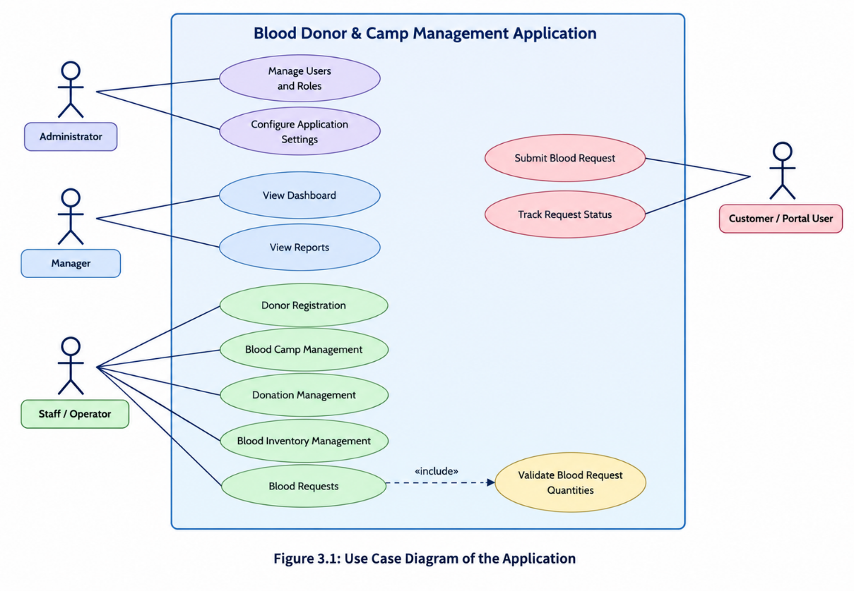
The use case model represents how users interact with the Blood Donor & Camp Management application. The primary activities include entering records, viewing reports, accessing the dashboard, and validating blood requests.

Figure 3.1: Use Case Diagram of Blood Donor & Camp Management Application here.

Table 3.5: Use Case Description
Field | Description
Use Case ID | UC-01
Use Case Name | Donor Registration
Actor(s) | Staff / Operator
Pre-condition | The user has access to the application.
Main Flow | 1. Open the Donor Registration form. 2. Enter donor details. 3. Submit the form. 4. The record is stored and can be viewed in the corresponding report.
Alternate Flow | If required information is missing or invalid, the record may not be accepted according to the form's configured validation.
Post-condition | The donor record is available in the Donor Registration report if successfully saved.
CHAPTER 4

SYSTEM DESIGN

4.1 System Architecture

The Blood Donor & Camp Management application follows a low-code architecture using Zoho Creator. The architecture consists of the user access layer, application layer, data layer, and business logic layer. These components work together to support record entry, record retrieval, dashboard visualisation, and blood request validation.

User Access Layer: Users access the application through a supported web browser. The current implementation was tested in Zoho Creator Live mode. Separate customer portals and custom role-based access have not been configured.

Application Layer: This layer contains the five forms: Donor Registration, Blood Camp Management, Donation Management, Blood Inventory, and Blood Requests. Corresponding reports allow users to view stored records. The dashboard contains a total donor count panel, two charts, and the Blood Requests report.

Business Logic Layer: Deluge scripting implements the blood request validation workflow. It checks the required and issued unit quantities and rejects invalid combinations according to the configured rules.

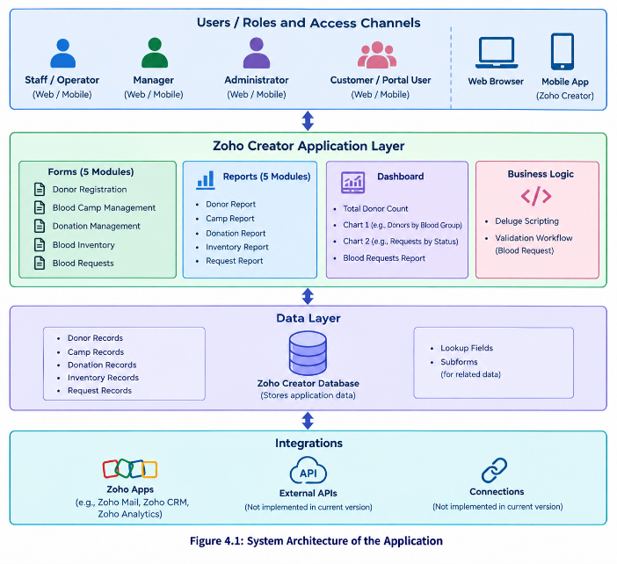
Data Layer: Zoho Creator stores the records submitted through the application's forms. The corresponding reports display the stored information. Blood inventory is maintained through its own form; automatic synchronisation after donations or blood issues is not implemented.
Figure 4.1: System Architecture of Blood Donor & Camp Management Application.

4.2 Data Model

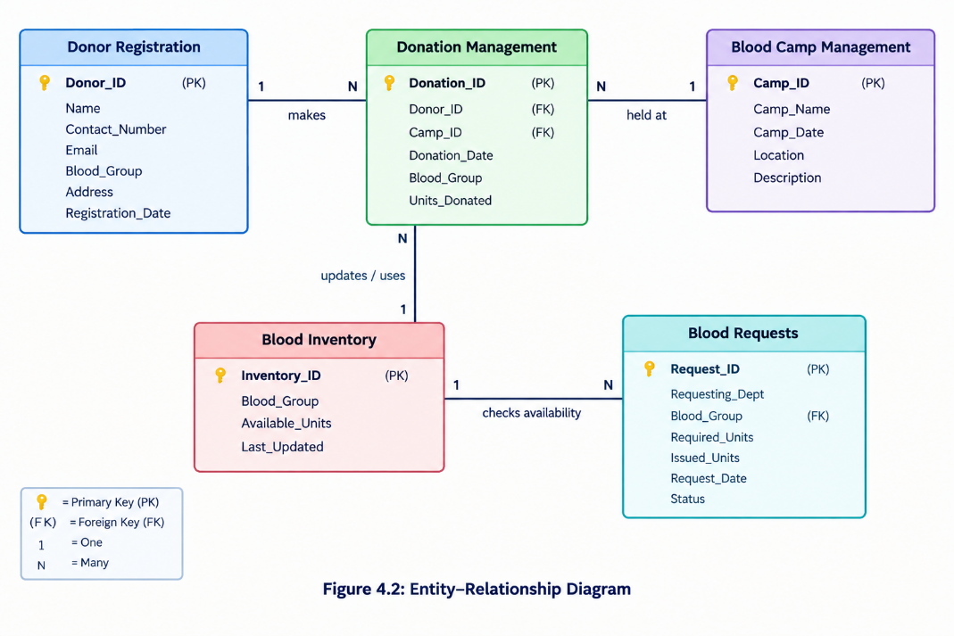
The data model organises the application's information into five main entities corresponding to the five Zoho Creator forms. Each form stores information for a specific activity, reducing the need to combine unrelated information in a single record.

Figure 4.2: Entity–Relationship Diagram of the Application

Table 4.1: Entities and Relationships
Entity (Form) | Key Fields | Related To | Relationship Type | Implemented Using
Donor Registration | Donor details and contact information | Donation Management | Conceptual one-to-many | Lookup, if configured
Blood Camp Management | Camp details, date, and location | Donation Management | Conceptual one-to-many | Lookup, if configured
Donation Management | Donor and donation details | Donor Registration, Blood Camp Management | Conceptual many-to-one | Lookup, if configured
Blood Inventory | Blood group and available units | Blood Requests | Logical association | Blood group and quantity fields
Blood Requests | Blood group, Units Required, Units Issued | Blood Inventory | Logical association | Validation workflow and inventory records

4.3 Form Design

The application contains five forms designed to collect and maintain blood donation-related information. The field specifications below describe the purpose and likely field types of each form. Exact field link names, mandatory settings, and additional validation rules should be verified against the actual form builder.
Table 4.2: Field Specification – Donor Registration Form
Field Label | Link Name | Field Type | Mandatory | Validation / Default | Remarks
Donor Name | Verify in Creator | Name or Single Line | Yes, if configured | Required entry | Identifies the donor
Contact Number | Verify in Creator | Phone | Verify | Valid phone format, if configured | Contact information
Email | Verify in Creator | Email | Verify | Email format, if configured | Optional contact detail
Blood Group | Verify in Creator | Drop Down | Verify | Available blood group options | Donor blood group
Address | Verify in Creator | Address or Multi Line | Verify | As configured | Donor location

Table 4.3: Field Specification – Blood Camp Management Form
Field Label | Link Name | Field Type | Mandatory | Validation / Default | Remarks
Camp Name | Verify in Creator | Single Line | Verify | As configured | Identifies the camp
Camp Date | Verify in Creator | Date | Verify | Valid date, if configured | Camp schedule
Location | Verify in Creator | Single Line or Address | Verify | As configured | Camp venue
Description | Verify in Creator | Multi Line | No, if optional | As configured | Additional information

4.4 Process and Workflow Design

The main automated process implemented in the application is blood request validation. It uses a Deluge workflow to check quantity-related conditions when a blood request is submitted.

The user opens the Blood Requests form.

The user enters the blood group, required units, and issued units.

The user submits the request.

The validation workflow checks whether required units are greater than zero.

It checks whether issued units are non-negative.

It checks whether issued units exceed the required quantity.

If a configured validation condition fails, the workflow rejects the request.

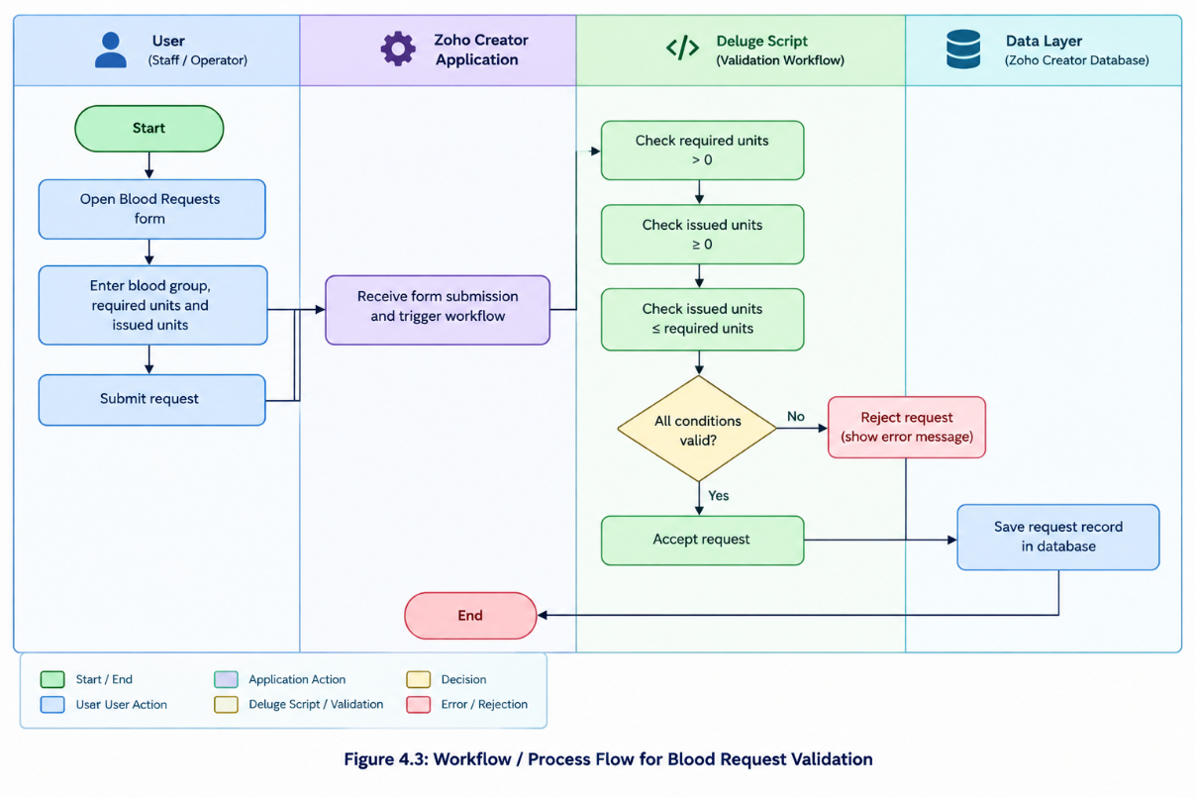
If all configured checks pass, the request is accepted.

Figure 4.3: Workflow / Process Flow for Blood Request Validation

4.5 User Interface and Navigation Design

The application's navigation is organised around the five forms, their corresponding reports, and a dashboard page. This structure allows users to access the relevant data-entry and record-viewing components from within Zoho Creator.

Main navigation structure:

Donor Registration: Enter and view donor information.

Blood Camp Management: Maintain camp records.

Donation Management: Maintain donation records.

Blood Inventory: View and maintain blood group and available-unit records.

Blood Requests: Enter and review blood requests.

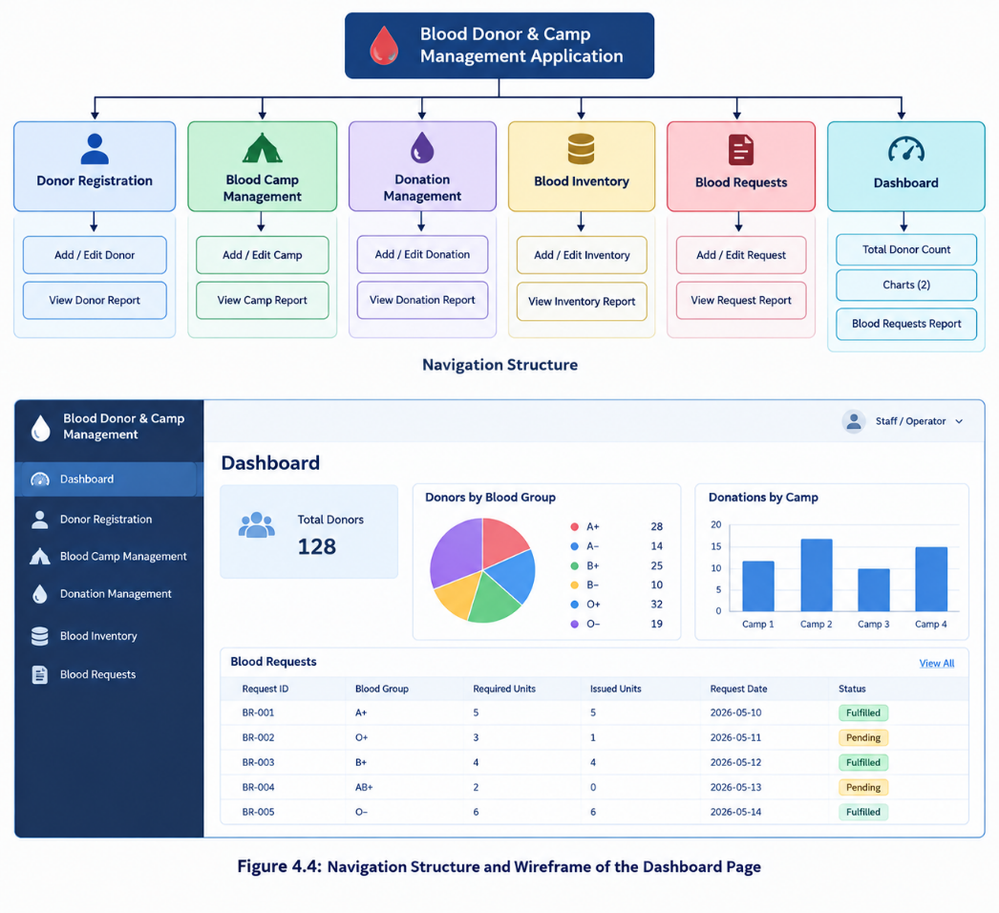
Dashboard: View the total donor count, two charts, and the Blood Requests report.

Figure 4.4: Navigation Structure and Wireframe of the Dashboard Page

4.6 Access Control Design

Access control determines which users can view or modify application information. Zoho Creator provides access-management capabilities, but the current project has not implemented custom administrator, manager, staff, or portal-user permission profiles. Therefore, the following table describes the current implementation status rather than claiming a configured role-based access-control system

Table 4.3: Role–Permission Matrix
Component | Administrator | Manager | Staff / Operator | Portal User
Donor Registration form | Platform access-dependent | Not separately configured | Platform access-dependent | Not configured
Blood Camp Management form | Platform access-dependent | Not separately configured | Platform access-dependent | Not configured
Donation Management form | Platform access-dependent | Not separately configured | Platform access-dependent | Not configured
Blood Inventory form | Platform access-dependent | Not separately configured | Platform access-dependent | Not configured
Blood Requests form | Platform access-dependent | Not separately configured | Platform access-dependent | Not configured
Reports | Platform access-dependent | Not separately configured | Platform access-dependent | Not configured
Dashboard | Platform access-dependent | Not separately configured | Platform access-dependent | Not configured
CHAPTER 5

IMPLEMENTATION

5.1 Application Setup

The Blood Donor & Camp Management application was developed using Zoho Creator, a low-code application development platform. The platform provides tools to create data-entry forms, reports, dashboards, and workflows with minimal traditional programming.

The application was organised into five main modules: Donor Registration, Blood Camp Management, Donation Management, Blood Inventory, and Blood Requests. Each module has a corresponding report for viewing the records stored through its form. A dashboard was also created to provide a consolidated view of selected information.

The application was configured using Zoho Creator's form builder, report builder, page builder, and Deluge workflow editor. The Blood Requests module includes a validation workflow to check the quantities entered before accepting a request. The application was tested in Live mode to verify form access, report display, dashboard components, and validation behaviour.

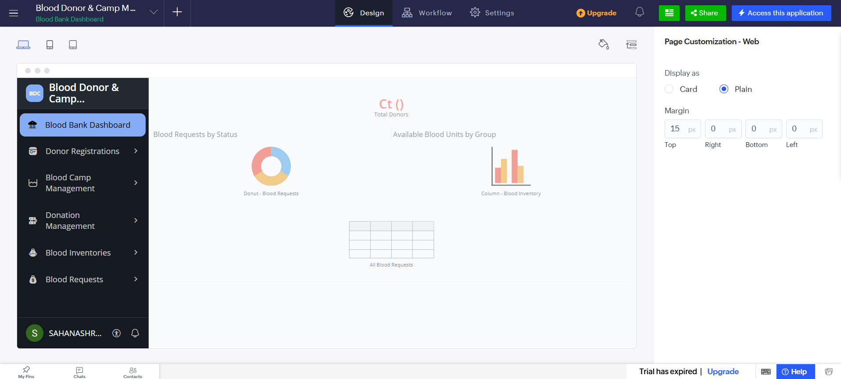
Figure 5.1: Application Home and Navigation Sections

5.2 Forms and Data Capture

Forms are the primary data-entry components of the application. They provide a structured way to collect and maintain information related to donors, blood donation camps, donations, blood inventory, and blood requests.

Five forms were created using the Zoho Creator form builder. The field names and field types should match the final version of each form in the application. The implemented forms are described below.

5.2.1 Donor Registration Form

The Donor Registration form is used to record information about individuals who register as blood donors. It provides a central location for storing donor details and supports retrieval through the corresponding Donor Registration report.

The form may contain fields such as donor name, contact information, blood group, and address, depending on the fields configured in the final application. These details help organise donor records for reference during blood donation activities.

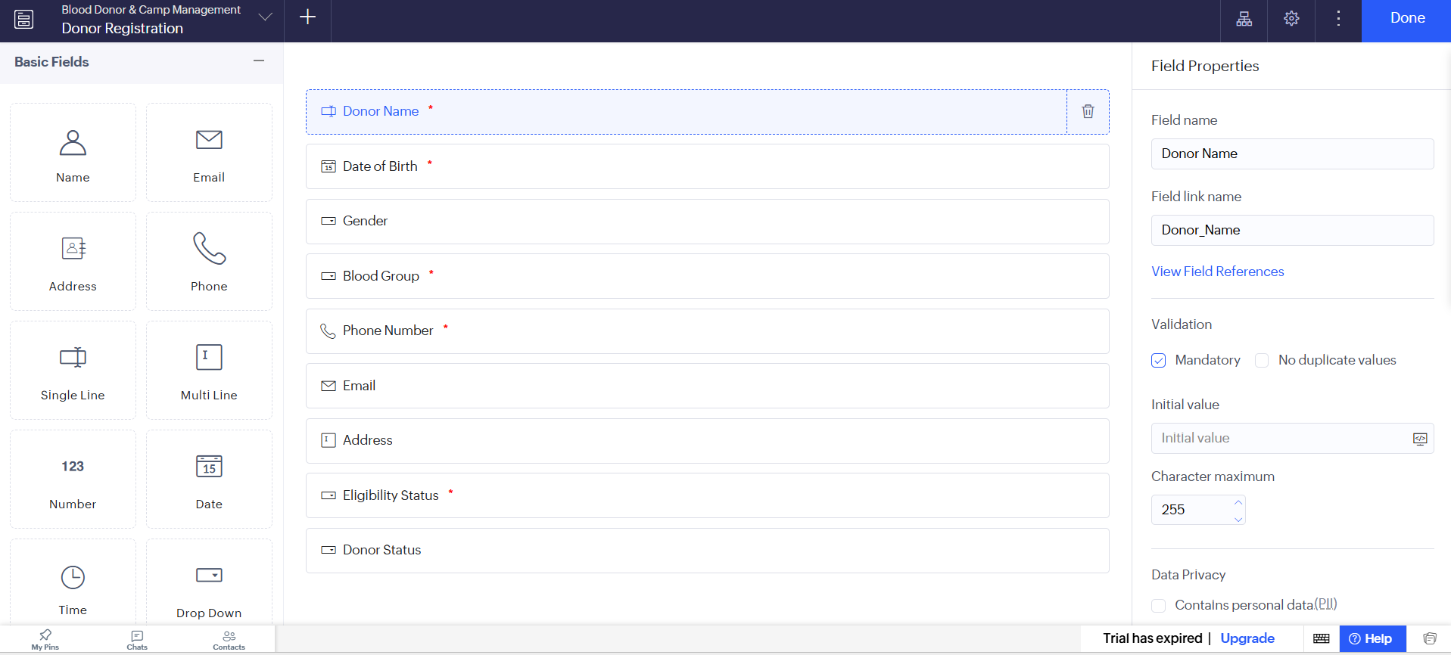
Figure 5.2: Donor Registration Form in the Form Builder
5.2.2 Blood Camp Management Form
The Blood Camp Management form stores information about blood donation camps. It helps organise camp-related records and provides a source for the corresponding report.
Camp details should be documented using the fields actually configured in the application, such as camp name, date, or location where applicable.
5.2.3 Donation Management Form
The Donation Management form is used to record information about blood donations. It provides a separate module for maintaining donation-related records instead of mixing them with donor registration or camp information.
The form supports the organisation of donation records for later viewing through the Donation Management report.
5.2.4 Blood Inventory Form
The Blood Inventory form maintains records of blood groups and their recorded availability. The fields used by the validation-related logic include Blood_Group and Available_Units.
This module provides a structured place to store inventory information. However, the current implementation does not automatically update inventory quantities whenever a donation or blood issue is recorded.
5.2.5 Blood Requests Form
The Blood Requests form records requests for blood. The fields used by the validation workflow include Blood_Group, Units_Required, and Units_Issued.
The form is connected to a Deluge validation workflow that checks the requested and issued quantities. A request is rejected if the required quantity is not greater than zero, the issued quantity is negative, or the issued quantity exceeds the required quantity.
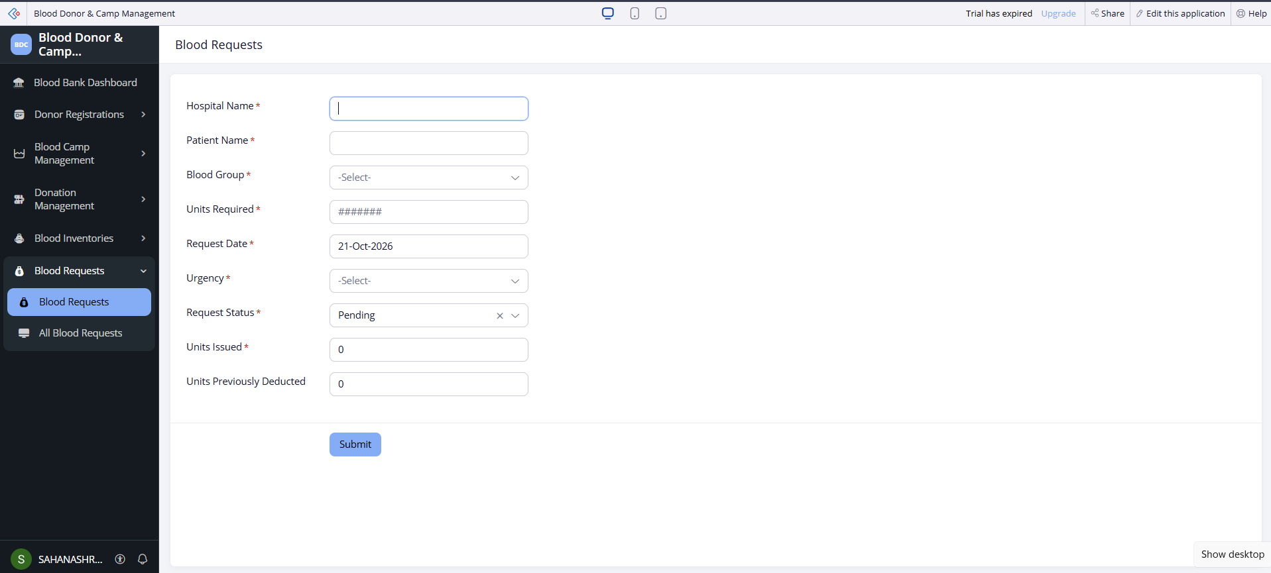
Figure 5.3: Blood Requests Form in Live Mode
The forms provide structured data capture across the five modules. Any additional field-level validation, lookup relationships, subforms, conditional display rules, or customised success messages should be documented only if they are configured in the application.

5.3 Reports

Reports provide a way to view and review the records submitted through the application's forms. A corresponding report was created for each of the five modules. These reports help users retrieve stored information without having to open the form builder.
Table 5.1: Reports Implemented
Report Name | Source Form | Purpose
Donor Registration Report | Donor Registration | View registered donor records
Blood Camp Management Report | Blood Camp Management | View blood camp records
Donation Management Report | Donation Management | View donation records
Blood Inventory Report | Blood Inventory | View recorded blood groups and available units
Blood Requests Report | Blood Requests | View submitted blood requests and their quantities

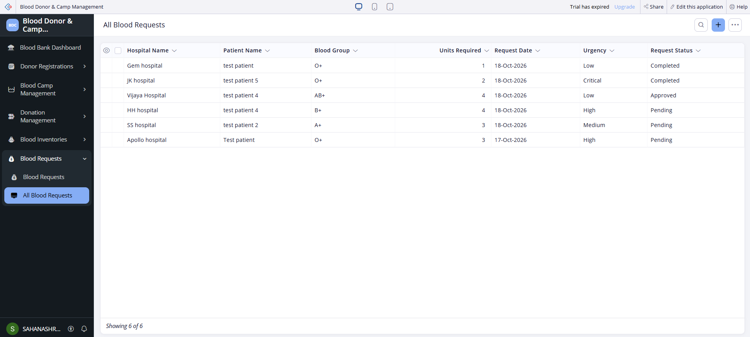

Figure 5.4: Blood Requests Report

5.4 Pages and Dashboards

A dashboard page was created using the Zoho Creator page builder. Its purpose is to present selected information from the application in one place, making it easier to review donor information and blood requests.

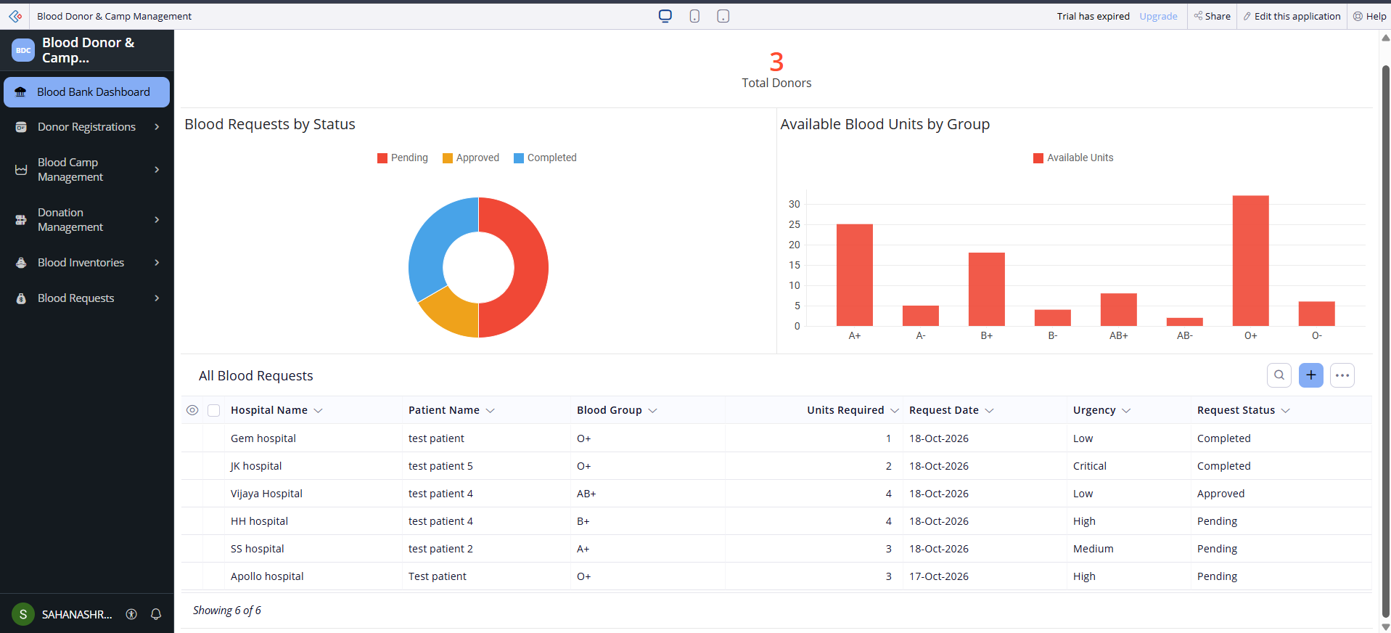

Figure 5.5: Blood Donor & Camp Management Dashboard

5.5 Deluge Scripting

Deluge is the scripting language used in Zoho Creator to implement workflow logic. In this application, Deluge was used to validate blood request quantities before a record could be accepted.
Table 5.2: Deluge Scripts Implemented
Script ID | Location / Trigger | Purpose | Concepts Used
DS-01 | Blood Requests form validation workflow | Validate required and issued blood units | Conditional statements, comparisons, alerts, submission cancellation

Code 5.1 Blood Request Quantity Validation
The following snippet illustrates the validation conditions implemented in the Blood Requests workflow. Confirm that the final saved workflow uses the same field link names and syntax before including this as the exact source code in the report.
// DS-01: Blood Requests validation
// Check the required and issued quantities.

if(input.Units_Required <= 0)
{
alert "Required units must be greater than zero.";
cancel submit;
}
else if(input.Units_Issued < 0)
{
alert "Issued units cannot be negative.";
cancel submit;
}
else if(input.Units_Issued > input.Units_Required)
{
alert "Issued units cannot exceed required units.";
cancel submit;
}

Explanation of the Script
The validation workflow checks the values entered in the Blood Requests form. First, it verifies that the required quantity is greater than zero. Next, it checks that the issued quantity is not negative. Finally, it ensures that the issued quantity does not exceed the requested quantity.
If any condition fails, the workflow displays an alert and cancels submission. Otherwise, the record can proceed through the normal form submission process, subject to any other configured rules.
The workflow was tested by entering an issued quantity greater than the required quantity. The application rejected the invalid submission, demonstrating that this validation condition was working in the tested scenario.
No notification script, scheduled reminder, or automatic inventory-update script is included as an implemented feature in this version.

5.6 Workflows and Automation

A form validation workflow was configured for the Blood Requests module. It checks the quantity fields before accepting the submitted record and helps prevent inconsistent quantity values.

Table 5.3: Workflows Implemented
Workflow Name | Type | Trigger / Event | Condition | Action
Blood Request Quantity Validation | Form validation workflow | Blood Requests form submission | Required units must be greater than zero; issued units must be nonnegative and no greater than required units | Display an error and cancel submission when a condition fails

The workflow was verified using an invalid quantity combination in which the issued units exceeded the required units. The application rejected the submission as expected.
Other automation features, such as scheduled reminders, approval processes, Blueprints, email notifications, and automatic inventory updates, are not included as completed features in the current implementation.
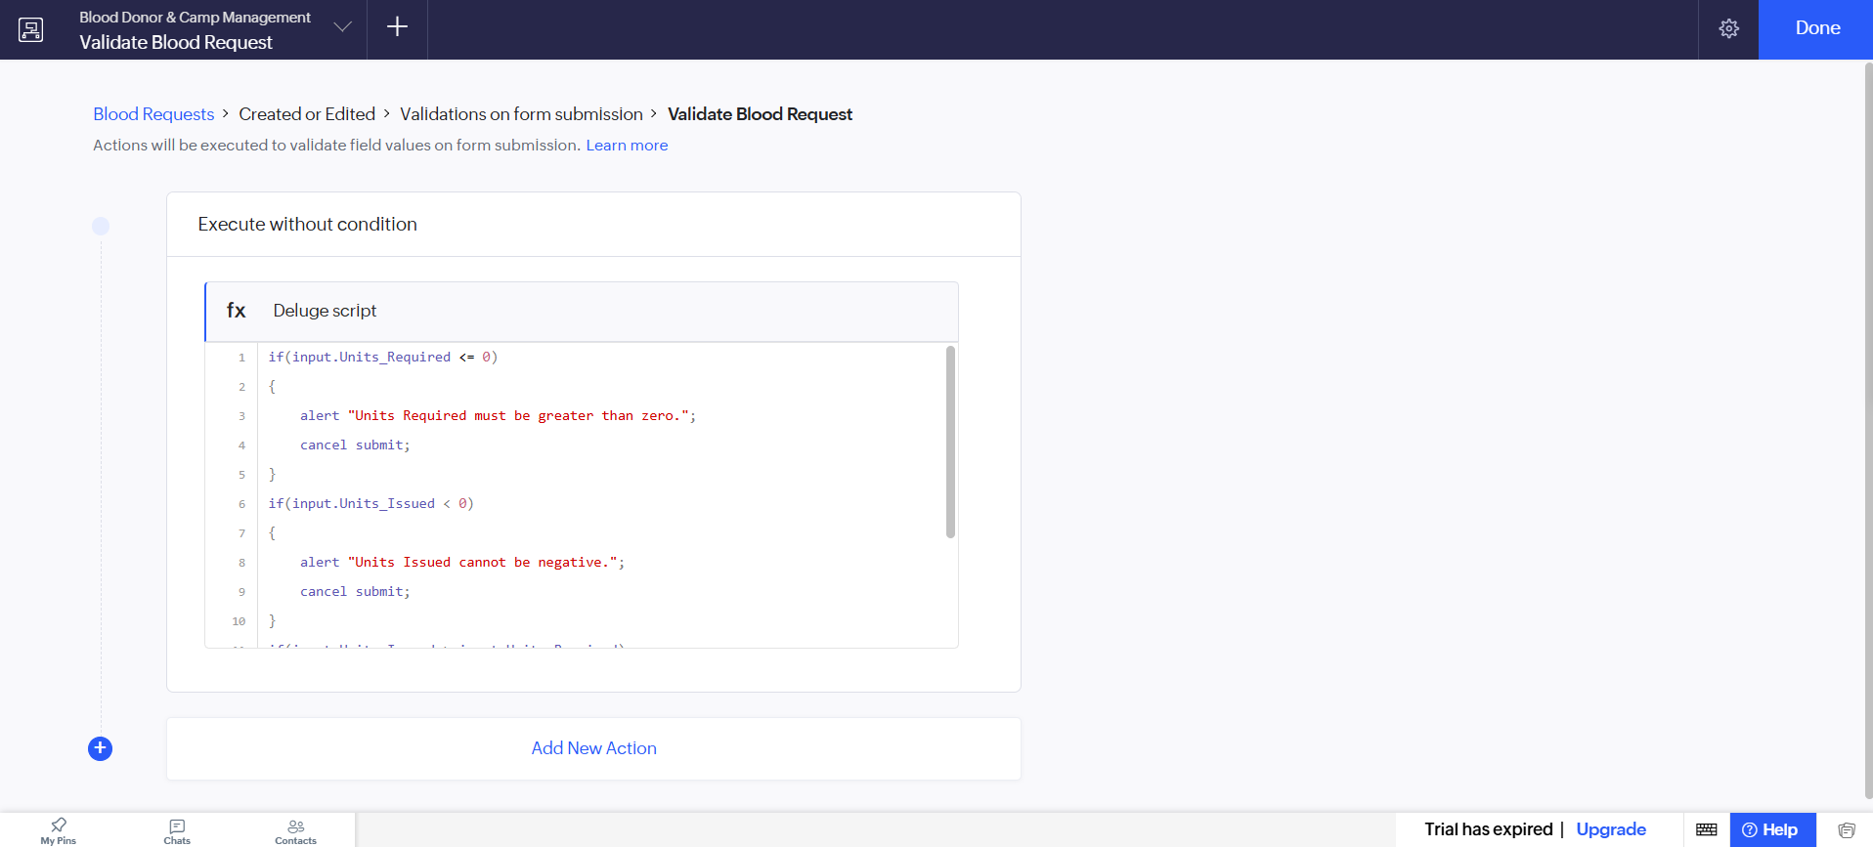
Figure 5.6: Blood Request Validation Workflow Configuration

5.7 Integrations

The current version of the Blood Donor & Camp Management application operates within Zoho Creator. Its forms, reports, dashboard, and Deluge validation workflow are implemented using the platform's built-in development features.

No external API, Zoho CRM synchronisation, webhook, payment service, or third-party application integration has been implemented in this version. Therefore, no external authentication configuration, API request, or Postman response is applicable to the current implementation.
Table 5.4: Integrations Implemented
Integration | Service / Endpoint | Method | Authentication | Status
External service integration | None | Not applicable | Not applicable | Not implemented
Zoho CRM synchronisation | None | Not applicable | Not applicable | Not implemented

External integrations could be considered in a future version to support features such as notifications or data exchange with other systems. These are possible extensions and are not part of the existing application.

5.8 User Management and Role-Based Access

The application was developed and tested in Zoho Creator. Custom role-based permissions, record-level access rules, and a customer portal have not been configured as part of the current implementation.

Access to the application therefore depends on the permissions and access settings provided by Zoho Creator for the account and application. The five forms, reports, dashboard, and validation workflow should not be described as having separate administrator, donor, hospital, or inventory-officer permissions unless those permissions are configured and tested.

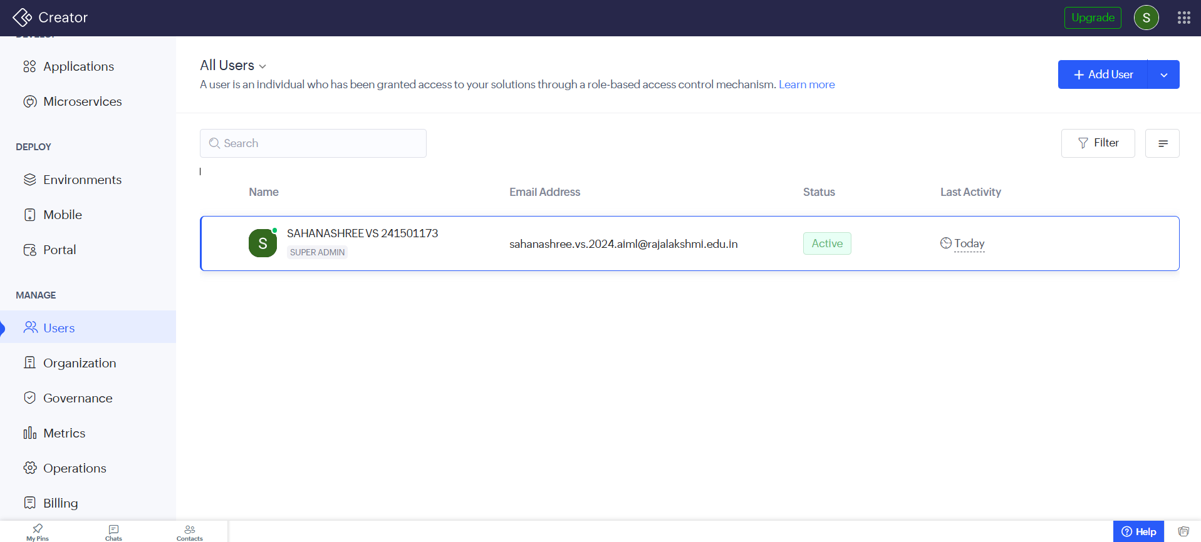
Figure 5.8: User and Permission Configuration

5.9 AI and Analytics Features

The application includes basic dashboard analytics through a donor-count panel and two charts. These components help present selected information in a visual format and provide an overview of the stored records.

The dashboard also displays the Blood Requests report, allowing users to review request information from the same page. The charts and count panel are used for data presentation; they should not be described as predictive analytics or AI-based decision-making features.

No AI prediction model, OCR feature, sentiment analysis, external Zoho Analytics integration, or AI-driven blood demand forecasting has been implemented in the current version.

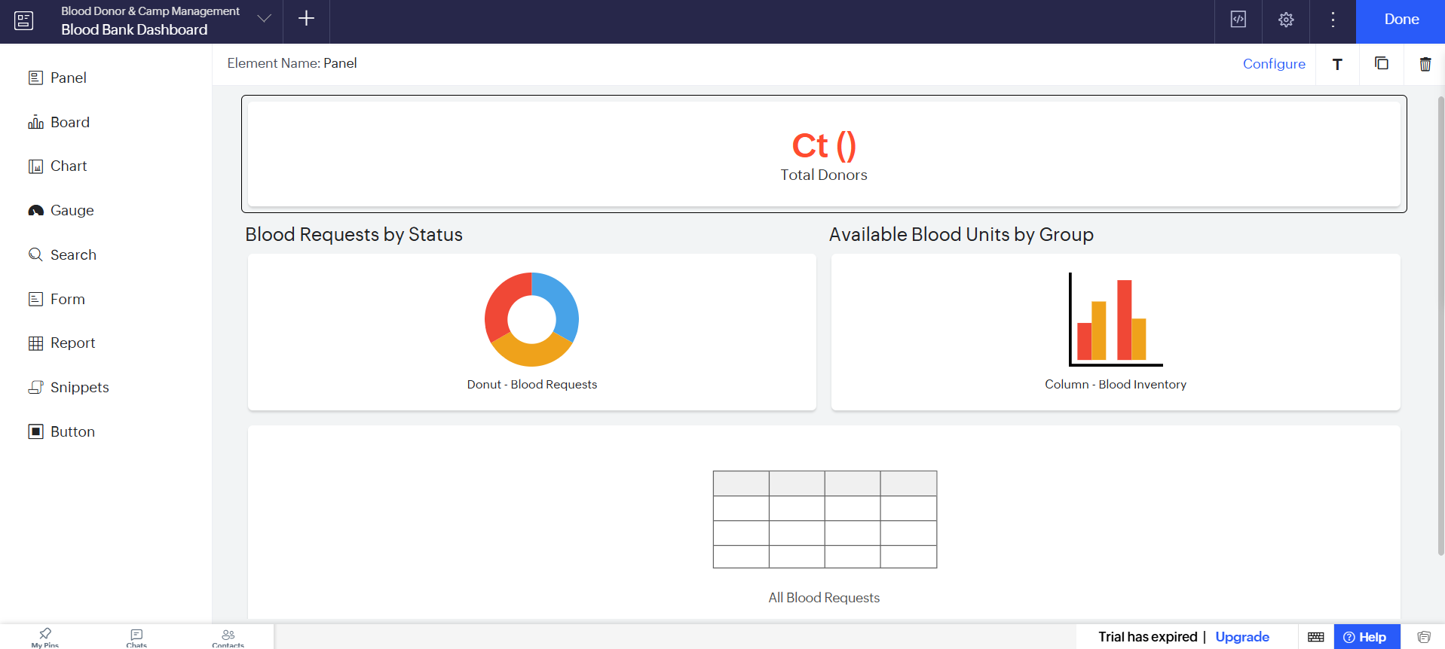
Figure 5.9: Dashboard Analytics Components

5.10 Pro-Code Extension

The application was developed using Zoho Creator's low-code tools and Deluge scripting. No separate Zoho Catalyst service, custom JavaScript widget, external application backend, or Creator REST API extension has been implemented in the current version.

Using a low-code platform made it possible to create forms, reports, a dashboard, and validation logic without building a separate application backend. Deluge was used where additional logic was required to validate blood request quantities.

In a future version, pro-code extensions could support external system integrations, advanced reporting, or more complex inventory-processing logic. These enhancements would require additional implementation and testing.

5.11 Mobile and Portal Access

The current project focuses on the Zoho Creator application, its forms, reports, dashboard, and validation workflow. A separate customer portal or dedicated mobile-specific interface has not been configured as part of this implementation.

Mobile access may be explored through Zoho Creator's supported access options, subject to the application's configuration and the user's account permissions. Any mobile compatibility or portal functionality should be reported as implemented only after it has been tested.

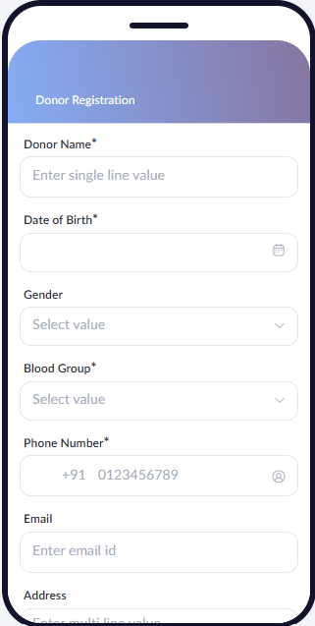
Figure 5.10: Application on Mobile
CHAPTER 6

TESTING AND DEBUGGING

6.1 Testing Strategy

Testing was carried out to check the functionality of the Blood Donor & Camp Management application developed using Zoho Creator. The main objective was to verify that the forms accepted appropriate data, reports displayed stored records, the dashboard presented the configured components, and the Blood Requests validation workflow rejected invalid quantity values.

The application was accessed in Live mode for functional testing. Testing focused on the following areas:

1. Form Testing: The five forms—Donor Registration, Blood Camp Management, Donation Management, Blood Inventory, and Blood Requests—were identified as the primary data-entry components. Each form should be tested for successful submission, required-field validation where configured, and correct storage of records.

2. Report Testing: The five corresponding reports should be checked to confirm that submitted records are displayed under the correct module.

3. Dashboard Testing: The dashboard should be checked for the donor-count panel, two charts, and the embedded Blood Requests report.

4. Workflow Testing: The Blood Requests validation workflow was tested using invalid quantity values. In particular, a request in which issued units exceeded required units was rejected. Other validation conditions should also be tested independently.

5. Negative Testing: Invalid quantities and missing required values should be tested to determine whether the application prevents inappropriate submissions. Tests involving unauthorised access are applicable only if separate user permissions have been configured.

6. User Acceptance Testing: Users should be asked to try the application and provide feedback about form clarity, navigation, and the usefulness of the dashboard. This testing should be documented after actual users have completed the evaluation.

The testing performed was primarily functional. Formal load testing, security penetration testing, external API integration testing, and role-based access testing were not performed because those capabilities were not implemented or verified in the current version.

6.2 Test Cases

The following test cases cover the five forms, reports, dashboard, and the implemented Blood Requests validation workflow. The FR references correspond to the functional requirements described in Chapter 3; adjust the identifiers if your Table 3.2 uses different numbering.
Table 6.1: Test Cases
TC ID | FR Ref. | Test Description | Input / Steps | Expected Result | Actual Result | Status
TC-01 | FR-01 | Submit a valid donor registration | Enter valid donor details and submit the form | Donor record is created | To be recorded after testing | Not Tested
TC-02 | FR-01 | Submit donor registration with a required field missing | Leave a configured mandatory field blank and submit | Form prevents submission and displays validation feedback | To be recorded after testing | Not Tested
TC-03 | FR-02 | Submit a valid blood camp record | Enter the configured camp details and submit | Camp record is created | To be recorded after testing | Not Tested
TC-04 | FR-03 | Submit a valid donation record | Enter the configured donation details and submit | Donation record is created | To be recorded after testing | Not Tested
TC-05 | FR-04 | Submit a valid inventory record | Enter a blood group and available units, then submit | Inventory record is created | To be recorded after testing | Not Tested
TC-06 | FR-05 | Submit a valid blood request | Enter a blood group, required units greater than zero, and issued units between zero and the required quantity | Request is accepted if all configured validations pass | To be recorded after testing | Not Tested
TC-07 | FR-06 / FR-07 | Enter issued units greater than required units | Set Units_Required to 3 and Units_Issued to 5, then submit | Submission is rejected | The application rejected the invalid submission during testing | Pass
TC-08 | FR-06 | Enter zero required units | Set Units_Required to 0 and submit | Submission is rejected | To be recorded after testing | Not Tested
TC-09 | FR-07 | Enter negative issued units | Set Units_Issued to a negative value and submit | Submission is rejected | To be recorded after testing | Not Tested
TC-10 | FR-08 | View the Donor Registration report | Open the Donor Registration report | Stored donor records are displayed | To be recorded after testing | Not Tested
TC-11 | FR-08 | View the Blood Camp Management report | Open the Blood Camp Management report | Stored camp records are displayed | To be recorded after testing | Not Tested
TC-12 | FR-08 | View the Donation Management and Blood Inventory reports | Open each report | Records from the corresponding forms are displayed | To be recorded after testing | Not Tested
TC-13 | FR-08 | View the Blood Requests report | Open the Blood Requests report | Blood request records are displayed | To be recorded after testing | Not Tested
TC-14 | FR-09 | Verify dashboard components | Open the dashboard and inspect its count panel, charts, and embedded report | The configured donor-count panel, two charts, and Blood Requests report are visible | To be recorded after testing | Not Tested
TC-15 | NFR-02 | Attempt access using an account without permission | Use a separate account that has not been granted access, if available | Access is denied according to the configured permissions | Separate role-based permissions have not been configured or verified | Not Applicable

The test cases cover normal input, invalid input, report access, dashboard display, and an access-control scenario. TC-07 is the confirmed successful negative test. The other test cases must be executed before their actual results and final status can be reported.

6.3 Debugging Deluge Scripts
Debugging was necessary to ensure that the Blood Requests validation workflow behaved correctly. The workflow checks the values entered for required units and issued units before allowing a record to proceed.
The validation logic uses conditional statements to compare the entered quantities. When an invalid condition is identified, the workflow displays an alert and cancels the submission. This helps prevent quantity combinations that violate the defined rules.
The following debugging methods can be used when investigating a Deluge workflow:
- Error messages: Review error messages shown during form submission to identify invalid values or workflow failures.
- Workflow configuration review: Check the workflow's trigger, conditions, field link names, and actions.
- Controlled test inputs: Submit valid and invalid quantity combinations separately to identify which condition is responsible for a rejection.
- Execution logs or debug output: Where available, inspect workflow execution details and use Deluge logging statements during development to examine relevant values.
One validation scenario was tested by entering an issued quantity greater than the required quantity. The application rejected the submission, confirming that the corresponding validation rule was operating as intended.
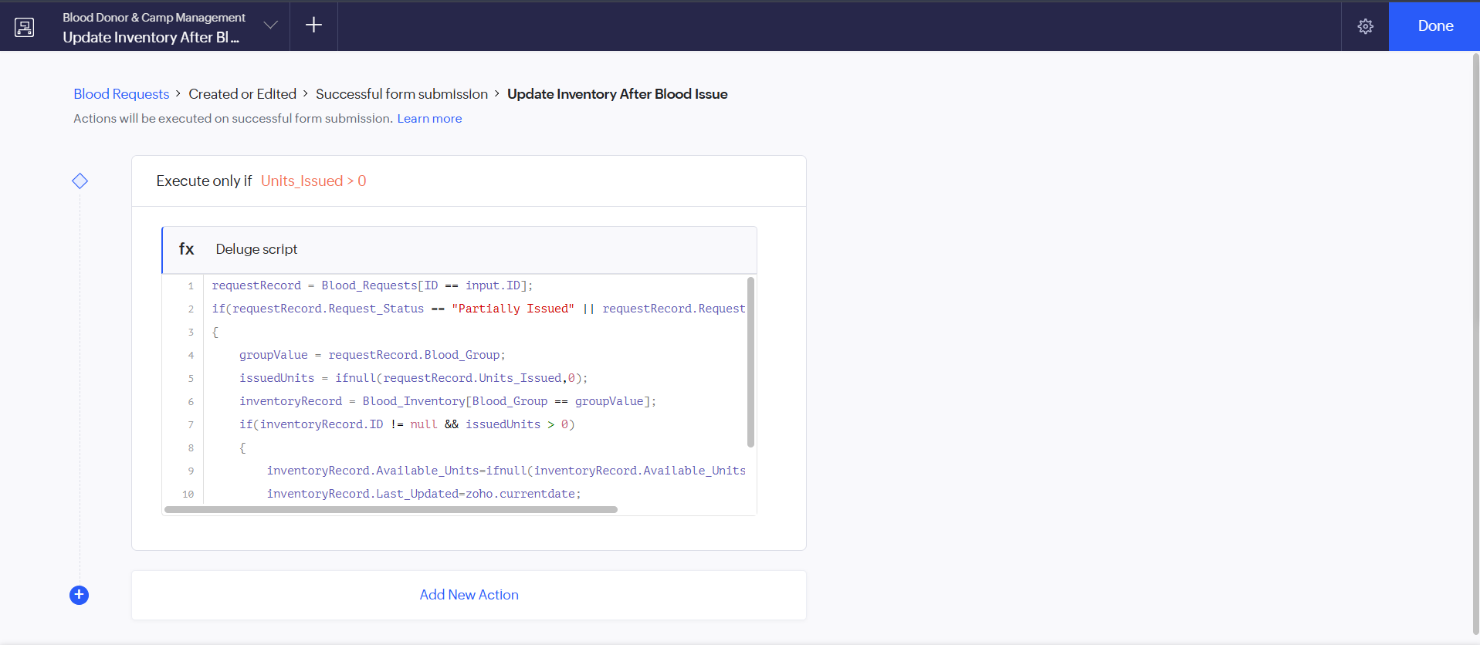
Figure 6.1: Deluge Debug Output / Validation Result

6.4 Defect Log

The defect log records issues discovered during development and testing, their causes, and the corrective action taken. Only confirmed defects and fixes should be included as completed items.
Table 6.2: Defect Log
Bug ID | Description | Root Cause | Fix Applied | Status
BUG-01 | A blood request with issued units greater than required units must not be accepted | The validation rule must enforce the relationship between Units_Issued and Units_Required | Implemented and tested a validation condition that rejects issued units greater than required units | Closed validation tested
BUG-02 | Automatic inventory updates were not completed | Inventory update workflows encountered errors or concerns about duplicate updates during development | Automatic inventory updates were left disabled to avoid incorrect or duplicate quantity changes | Open future enhancement
BUG-03 | Other validation edge cases require separate verification | Zero required units and negative issued units need individual test execution | Verify each condition through controlled submissions and record the results | Pending testing

BUG-01 documents the confirmed validation scenario. BUG-02 describes a known implementation limitation rather than a completed fix. BUG-03 is a pending verification item and should be updated after testing.

6.5 User Acceptance Testing

User Acceptance Testing (UAT) evaluates whether the application is understandable and suitable for its intended users. For this project, users should be asked to navigate the forms and reports, inspect the dashboard, and try submitting a blood request with valid and invalid quantities.

The feedback should focus on the ease of entering records, clarity of field labels, ability to find stored information, and usefulness of the dashboard. Since actual feedback from two end users has not yet been provided, the table below is a template to complete after the evaluation.
Table 6.3: User Acceptance Feedback
User | Role Tested | Feedback | Action Taken
User 1 | Staff / Operator (proposed test role) | To be collected after using the application | To be determined from feedback
User 2 | Staff / Operator (proposed test role) | To be collected after using the application | To be determined from feedback
CHAPTER 7

DEPLOYMENT, SECURITY AND GOVERNANCE

7.1 Environments and Deployment Strategy

The Blood Donor & Camp Management application was developed using Zoho Creator. The forms, reports, dashboard, and Deluge validation workflow were configured within the Zoho Creator environment. The application was accessed in Live mode to test its main features, including data entry, report viewing, dashboard display, and blood request validation.

Live mode was used to verify the application during development. However, accessing an application in Live mode does not, by itself, establish that a separate production deployment has been completed. Separate Development, Stage, and Production environments, a formal publishing process, and a rollback procedure have not been confirmed for the current project.

A recommended deployment strategy for future versions is to develop and test changes before making them available to intended users. Changes should first be checked using sample data, followed by validation of forms, reports, dashboard components, and workflows. Before releasing an updated version, the developer should retain a backup or export where supported, record the changes, and verify the application after publishing.

If a defect is discovered after a release, the developer should identify the affected component, restore a known-good version where the platform's available facilities permit, or correct the configuration and retest it. Any restoration procedure should be verified before being relied upon.
Table 7.1: Deployment Checklist
S. No. | Checklist Item | Done (✓)
1 | All planned test cases executed in the available test environment | ✓
2 | Sample or test data reviewed and removed or isolated where appropriate | ✓
3 | User access and permissions reviewed | ✓
4 | External connections authorised, if applicable | ✓
5 | Required workflows checked and enabled | ✓
6 | Application access in Live mode verified | ✓
7 | Version or release notes recorded | ✓
The checklist should be updated after each item has been verified. The Live mode entry records the testing already described in the project; it does not mean the application has undergone a formal production release.

7.2 Performance Optimisation

Performance optimisation aims to keep forms, reports, dashboards, and workflows responsive as the amount of stored information increases. In the current project, the main components are five forms, five corresponding reports, a dashboard, and the Blood Requests validation workflow.

The validation workflow performs comparisons on the entered quantity values. This is a simple validation task and does not require a separate inventory-fetch operation to enforce the three confirmed quantity rules. Automatic inventory updating was not completed, so no performance improvement related to inventory-update scripts can be claimed. Potential optimisation practices for future development include limiting reports to relevant columns, applying suitable filters to large reports, avoiding repeated database fetches inside loops, and using bulk operations when processing multiple records. These techniques should be introduced only where needed and tested against the application's actual data and workflows.

No measured execution times, response-time benchmarks, or before-and-after performance measurements were collected. Therefore, the project's performance is described in terms of its implementation structure rather than quantified improvement.

Table 7.2: Performance Optimisation Results
Optimisation Applied | Component | Before | After | Improvement
Quantity comparisons used for request validation | Blood Requests validation workflow | Not measured | Not measured | Correctness was tested; performance improvement not measured
Report filtering and column reduction | Five reports | Not measured | Not measured | To be evaluated if these changes are configured
Avoiding repeated data fetches in loops | Deluge scripts | Not applicable to the confirmed validation logic | Not applicable to the confirmed validation logic | No measured improvement
Dashboard component review | Dashboard | Not measured | Not measured | Visual components were created; response time was not benchmarked

The table distinguishes the implemented validation logic from possible optimisation work. Future performance testing could compare response times using the same data volume and test procedure before and after a specific optimisation.

7.3 Security Features

Security is important because the application stores donor contact information and records related to blood donations, inventory, and requests. Access to this information should be restricted to authorised users.

The current implementation uses Zoho Creator as its application platform. Custom role-based permissions, record-level access rules, encrypted custom fields, OAuth connections, IP restrictions, and customer portal security have not been confirmed as configured features in this project. No external integration was implemented, so there are no project-specific OAuth connections or API credentials to document.

The application should be shared only through appropriate Zoho Creator access settings. Before use with real donor information, the developer should review who can access the application and its reports, whether sensitive information is visible to all permitted users, and whether the account's available authentication and security controls meet the project's needs.

Table 7.3: Security Controls Implemented
Security Control | Where Applied | Threat Mitigated / Status
Zoho Creator account and application access settings | Access to the application | Access depends on the configured platform permissions; project-specific settings require verification
Custom role-based permissions | Not configured in the confirmed implementation | Separate access restrictions by user role are not implemented
Record-level permission criteria | Not configured | Record-specific restrictions have not been implemented or verified
Encrypted custom fields | Not configured or verified | No project-specific encrypted-field configuration can be claimed
OAuth connections | No external integrations | Not applicable to the current implementation
IP or domain restrictions | Not configured or verified | No project-specific restrictions can be claimed
Customer portal security | No customer portal configured | Not applicable to the current implementation

The current application should be treated as a project demonstration until its access settings and handling of sensitive data have been reviewed. Future improvements may include separate permissions for staff, restricted access to donor contact details, and an appropriate access policy for any external users.

7.4 Governance and Administration

Governance and administration cover the maintenance of application records, changes to forms and workflows, backups, access management, and responsibility for ongoing operation.

The application was developed within Zoho Creator, where its forms, reports, dashboard, and Deluge workflow are maintained. Changes to these components should be reviewed and tested before being used with real records. A simple naming convention, such as using descriptive names for forms and reports and consistent identifiers for workflows, can make maintenance easier.

The Blood Requests validation workflow should be checked whenever the related form fields or quantity rules change. The five reports and dashboard should also be reviewed if the structure of their source forms is modified. This helps ensure that the displayed information remains consistent with the underlying records.

A backup or export should be created periodically using the options available to the account. The developer should verify what each export contains, because an application-structure export may not include the underlying data records. The availability of backup and recovery features may depend on the account's plan and permissions.

Custom audit-trail configuration, a formal change-approval process, licence management procedures, and a documented backup schedule have not been confirmed as implemented. These should be established before the application is used for ongoing operational management.
CHAPTER 8

RESULTS AND DISCUSSION

8.1 Application Output

The Blood Donor & Camp Management application was developed using Zoho Creator to organise donor registration, blood camp management, donation records, blood inventory, and blood requests. The application provides five forms and their corresponding reports, along with a dashboard containing a donor-count panel, two charts, and the Blood Requests report.

The following scenario demonstrates the intended workflow using sample data. It illustrates how information can be entered, stored, viewed, and validated within the application. It does not imply that automatic inventory updates or approval workflows are available.

Step 1: Register a Donor

The Donor Registration form is used to enter and store donor information. The user fills in the configured fields and submits the form. The resulting record can be viewed through the Donor Registration report.

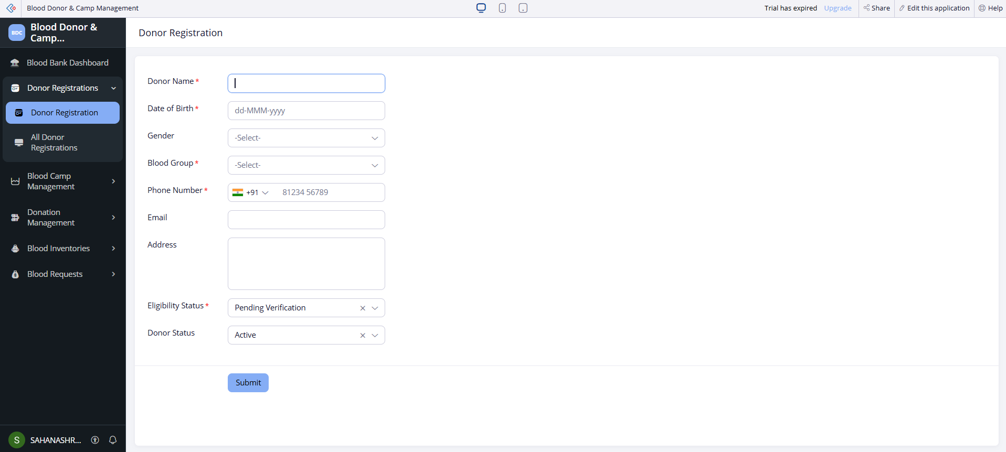
Figure 8.1: Donor Registration Form
Step 2: Record a Donation or Manage Inventory
The Donation Management form provides a separate place to record donation-related information. The Blood Inventory form stores blood group and available-unit records. These modules organise the information required for reviewing donation and inventory records.
In the current implementation, inventory quantities are not automatically updated through the donation or blood issue workflows. Any change to inventory records must therefore follow the application's available data-entry process.
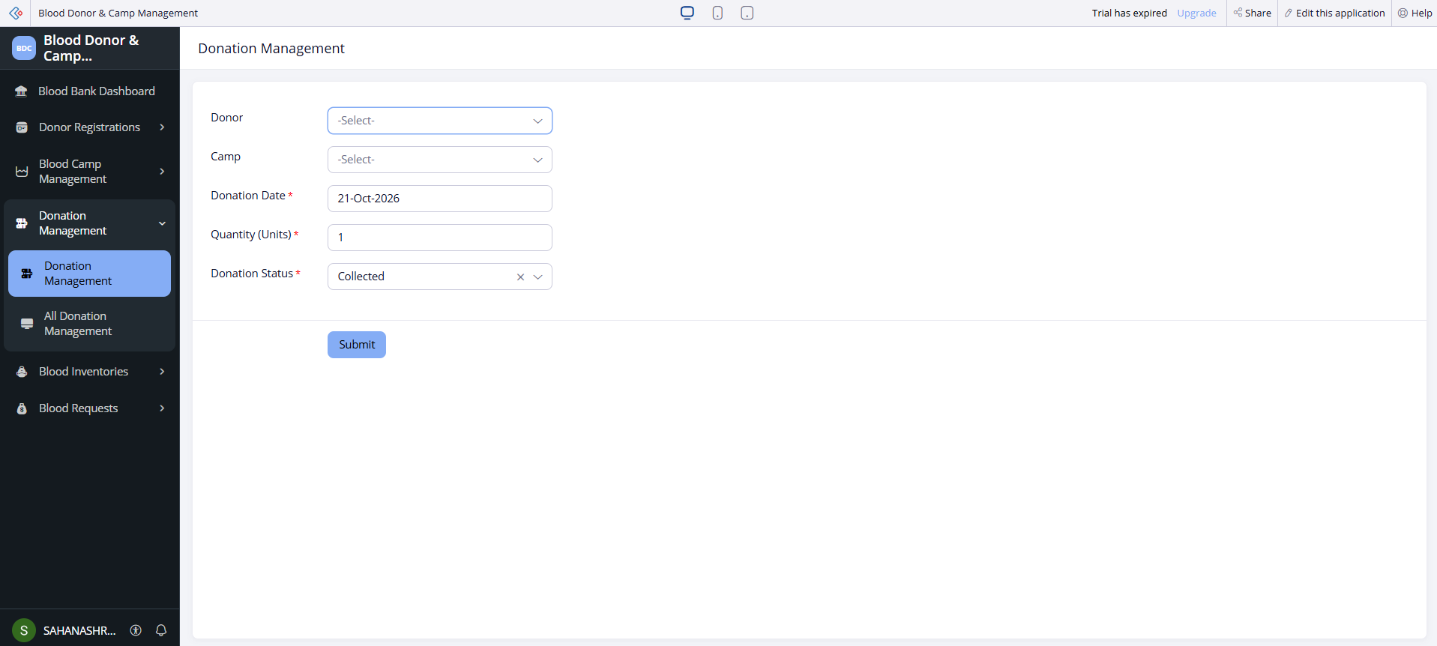
Figure 8.2: Donation Management or Blood Inventory Module
Step 3: Submit and Validate a Blood Request
The Blood Requests form records the blood group, required units, and issued units. A Deluge validation workflow checks that the required quantity is greater than zero, the issued quantity is not negative, and the issued quantity does not exceed the required quantity.
When an invalid quantity combination is entered, the workflow displays an alert and cancels submission. This behaviour was tested using a request in which the issued quantity exceeded the required quantity.
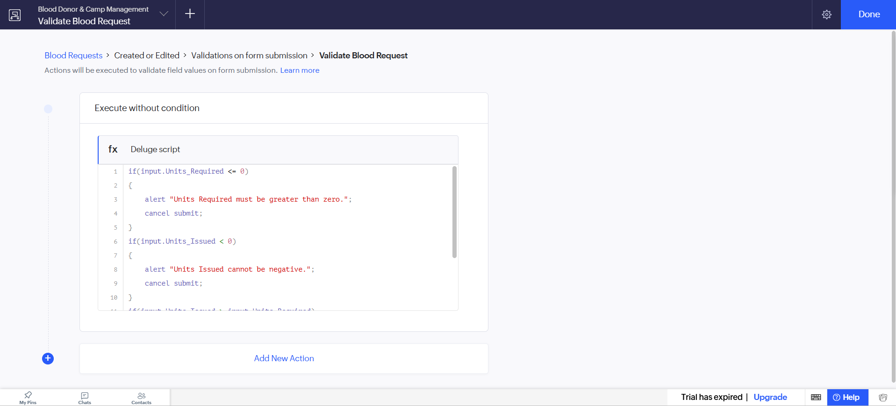
Figure 8.3: Blood Request Validation
After the request has been submitted successfully, its record can be reviewed in the Blood Requests report. The dashboard provides a consolidated view of selected application information through the donor-count panel, two charts, and the embedded Blood Requests report.
8.2 Achievement of Objectives

The project aimed to develop a structured application for managing blood donation-related information and validating blood requests. The following table maps the main objectives to the implemented components and available evidence.
Table 8.1: Mapping of Objectives to Outcomes
Objective | Implemented Through | Outcome / Evidence
Objective 1: Organise donor and camp information | Sections 5.2 and 5.3 — Donor Registration and Blood Camp Management forms and reports | Dedicated forms and corresponding reports were created for storing and viewing records
Objective 2: Maintain donation, inventory, and request records | Sections 5.2 and 5.3 — Donation Management, Blood Inventory, and Blood Requests | Separate modules and reports were created for these records
Objective 3: Validate blood request quantities | Sections 5.5 and 5.6 — Deluge scripting and workflow | A request with issued units greater than required units was rejected during testing
Objective 4: Provide a consolidated visual overview | Section 5.4 — Dashboard | A dashboard was created with a donor-count panel, two charts, and the Blood Requests report

8.3 Comparison with the Existing System

A manual or spreadsheet-based process may store donor details, camp information, donations, inventory, and requests in separate records. The proposed application provides dedicated forms and reports for these categories within a single Zoho Creator application.
Table 8.2: Existing System versus Proposed Application
Parameter | Existing System | Proposed Application | Improvement
Record organisation | Information may be maintained in separate spreadsheets or paper records | Five dedicated forms and corresponding reports | Provides a more structured way to organise information
Manual steps | Records may need to be entered and retrieved across separate files | Records can be entered and viewed through the relevant application module | Centralises the record-handling process; reduction in steps not measured
Report generation | Information may need to be searched or compiled manually | Corresponding reports display records stored in each module | Simplifies access to stored records; time saved not measured
Data accessibility | Access depends on the availability and organisation of individual files | Selected records can be viewed through the application's reports | Provides a common application interface, subject to access permissions
Blood request validation | Quantity checks may rely on manual review | Deluge workflow rejects specified invalid quantity combinations | Enforces the implemented quantity rules during form submission
Visual overview | Information may need to be reviewed separately | Dashboard contains a donor-count panel, two charts, and the Blood Requests report | Provides a consolidated visual view of selected information
Inventory updating | Updates may be recorded manually | Inventory records are maintained through the Blood Inventory module | Automatic synchronisation is not implemented

The comparison indicates that the proposed application improves the organisation of records by providing a common interface and dedicated modules. Its validation workflow also reduces reliance on manual checking for the specific quantity conditions it enforces.
The comparison is qualitative. No controlled time measurements or quantitative evaluation of error rates was conducted, so numerical claims about efficiency or accuracy cannot be made.

8.4 Limitations of the Low-Code Approach

Zoho Creator made it possible to build the application using forms, reports, a dashboard, and Deluge scripting without developing a separate backend from the beginning. However, the project also highlighted several considerations associated with low-code development.

1. Platform dependency: The application relies on Zoho Creator's tools, data structures, workflow engine, and account capabilities. Moving it to another platform may require redesigning forms, reports, and business logic.

2. Customisation constraints: The application interface is built using the platform's available form, report, and page-building features. Highly specialised layouts or interactions may require additional customisation or external development.

3. Workflow debugging: Deluge scripts require correct field link names, conditions, and workflow configuration. Errors in these areas can prevent a workflow from behaving as intended. Testing invalid input values helped verify the Blood Requests validation rule.

4. Complex automation: The project includes quantity validation but does not include completed automatic inventory synchronisation. Reliable inventory automation would require additional logic to prevent duplicate updates, handle concurrent requests, and maintain consistency when a workflow fails.

5. Performance and usage limits: The current project was not subjected to formal load testing. The effect of platform-specific execution limits, record volumes, and account-plan restrictions therefore remains unevaluated.

8.5 Reflection on the No-Code → Low-Code → Pro-Code Spectrum

The project demonstrates how an application can be built across different levels of development using Zoho Creator.

No-Code Configuration

The forms, reports, and dashboard were created primarily through visual configuration. The form builder was used to define data-entry screens, the report builder to present stored records, and the page builder to assemble the dashboard. These activities required configuration rather than writing a separate application backend.

Low-Code Development

Deluge scripting was used to implement the Blood Requests validation workflow. Conditional statements and quantity comparisons enforced the rules for required and issued units. This illustrates how low-code scripting can extend visual configuration with application-specific business logic.

Pro-Code Development

A separate pro-code backend, custom JavaScript widget, Zoho Catalyst service, and Creator REST API extension were not implemented in the current project. Such technologies could become useful if the application requires complex inventory processing, integration with external hospital systems, advanced access control, or processing that exceeds the needs of the existing low-code implementation.

CHAPTER 9

CONCLUSION AND FUTURE ENHANCEMENTS

9.1 Conclusion

The Blood Donor & Camp Management application was developed using Zoho Creator to organise information related to donor registration, blood donation camps, donations, blood inventory, and blood requests. The application contains five forms and five corresponding reports, together with a dashboard featuring a donor-count panel, two charts, and the Blood Requests report. These components provide a structured interface for entering, storing, and viewing blood donation-related records.

A Deluge validation workflow was implemented for the Blood Requests form to check required and issued quantities. Testing confirmed that a request with issued units greater than required units was rejected. The project demonstrates how a low-code platform can combine visual application development with scripting to implement a defined business rule. Automatic inventory updates, external integrations, custom role-based access, and formal performance evaluation remain outside the completed implementation.

9.2 Future Enhancements

The following improvements could extend the functionality and reliability of the application.

Automatic Inventory Management: Implement and test workflows that update inventory after donations and blood issues, with safeguards against duplicate updates and inconsistent quantities.

Blood Availability Checks: Validate requests against recorded inventory availability before confirming an issue. This would require reliable inventory synchronisation and appropriate handling of concurrent requests.

Notifications and Alerts: Add notifications for relevant events, such as new requests or low recorded inventory levels, after configuring and testing the required workflow.

9.3 Learning Outcomes and Career Relevance

Developing the Blood Donor & Camp Management application provided practical experience in low-code application development using Zoho Creator. The project involved organising information into forms, presenting records through reports, creating a dashboard, and implementing a validation workflow using Deluge.

The work also highlighted the importance of testing, debugging, and documenting application behaviour. Testing the Blood Requests workflow demonstrated how business rules can be translated into conditional logic and verified using invalid input. Preparing the deployment, security, and governance sections further emphasised the need to distinguish implemented functionality from planned improvements.

These skills are relevant to several career pathways:

Citizen Developer: Creating business applications using visual development tools to address practical organisational needs.

Low-Code Developer: Designing forms, reports, dashboards, and workflows while using scripting for additional logic.

Solutions Consultant: Understanding user requirements and translating them into an application structure and workflow.

Automation Engineer: Developing, testing, and maintaining workflow-based business processes.

Application Support or Business Systems Analyst: Documenting system behaviour, investigating defects, validating requirements, and identifying future improvements.

Overall, the project provided a foundation in application design, low-code scripting, functional testing, and technical documentation. It also demonstrated the importance of careful validation and responsible handling of information when developing applications for a domain such as blood donation management.

REFERENCES

[1] a. Bucaioni, a. Cicchetti, and f. Ciccozzi, “modelling in low-code development: a multi-vocal systematic review,” software and systems modeling, vol. 21, pp. 1959–1981, 2022, doi: 10.1007/s10270-021-00964-0.

[2] d. Pinho, a. Aguiar, and v. Amaral, “what about the usability in low-code platforms? A systematic literature review,” journal of computer languages, vol. 74, art. No. 101185, 2023, doi: 10.1016/j.cola.2022.101185.

[3] zoho corporation, “understand application,” zoho creator help documentation. [online]. Available: https://help.zoho.com/portal/en/kb/creator/developer-guide/creating-applications/understand-applications/articles/understand-application. [accessed: oct. 20, 2026].

[4] zoho corporation, “understanding workflows,” zoho creator help documentation. [online]. Available: https://help.zoho.com/portal/en/kb/creator/developer-guide/workflows/understand-workflows/articles/understand-workflows. [accessed: oct. 20, 2026].

[5] zoho corporation, “deluge,” zoho developer documentation. [online]. Available: https://www.zoho.com/deluge/. [accessed: oct. 20, 2026].

[6] world health organization, “blood safety and availability,” jun. 12, 2026. [online]. Available: https://www.who.int/news-room/fact-sheets/detail/blood-safety-and-availability. [accessed: oct. 20, 2026].

APPENDIX A – ZOHO CREATOR FEATURE COVERAGE CHECKLIST
Table A.1: Feature Coverage Checklist
Unit | Zoho Creator Feature | Done | Where in the Application | Report Section
I | Application created & sections/menu organised | Y | Zoho Creator application | 5.1
II | Forms with ≥ 8 distinct field types | Y | Donor Registration, Blood Camp Management, Donation Management, Blood Inventory, Blood Requests | 5.2
II | Lookup field (relationship between forms) | Y | Verify lookup fields in the form builder | 4.2, 5.2
II | Subform (parent–child data) | Y | Not implemented/verified | 4.2, 5.2
II | Field validations / layout rules | Y | Blood Requests validation workflow | 5.2
II | List report with filter, grouping, custom action | Y | Five module reports; advanced features not verified | 5.3
II | Kanban / Calendar / Timeline / Map report | N | Not implemented | 5.3
II | Pivot table / chart report | Y | Dashboard charts exist; report-type charts not verified | 5.3
II | Page / dashboard built with UI Builder | Y | Dashboard page | 5.4
II | Deluge – form events (validate / success / field actions) | Y | Blood Requests validation | 5.5
II | Deluge – functions, fetch, loops, collections | N | Not implemented/verified | 5.5
II | Email / in-app notifications | N | Not implemented | 5.5, 5.6
II | Form workflow | Y | Blood Requests validation workflow | 5.6
II | Scheduled workflow | N | Not implemented | 5.6
II | Approval process | N | Not implemented | 5.6
II | Blueprint | N | Not implemented | 5.6
II | Batch / report workflow | N | Not implemented | 5.6
II | Testing & debugging evidence | Y | Blood request validation test | 6
III | Integration with a Zoho service | N | Not implemented | 5.7
III | Connection / REST API call (invokeurl) | Y | Blood request validation test | 5.7
III | Webhook or Creator REST API | N | Not implemented | 5.7
III | Users, roles and permission profiles | Y | Custom roles not configured | 5.8
III | Record-level access criteria / customer portal | N | Not implemented | 5.8
III | Zia / AI feature | N | Not implemented | 5.9
III | Analytics (charts / Zoho Analytics) | Y | Dashboard with two charts | 5.9
IV | Performance optimisation applied & measured | Y | No performance measurements recorded | 7.2
IV | Deployment across environments | Y | Live mode used; separate environments not verified | 7.1
IV | Security controls (encryption, OAuth, permissions) | Y | Custom security controls not configured/verified | 7.3
IV | Governance (audit trail, administration) | Y | Formal governance controls not verified | 7.4
V | Pro-code extension (Catalyst / widgets / custom functions) | N | Not implemented | 5.10
V | Low-code limitations & spectrum analysis | Y | Limitations and development-spectrum discussion | 8.4, 8.5
— | Mobile app / portal access | Y | Separate portal/mobile interface not configured | 5.11

Total features implemented: 22 / 32

APPENDIX B – COURSE OUTCOME MAPPING

The self-assessed level should reflect your actual learning and implementation. Use the following suggested levels, and adjust them if they do not match your experience.
Table B.1: Mapping of Course Outcomes to Report Chapters
CO | Course Outcome Statement | Evidenced In | Self-Assessed Level | Examiner Level
CO1 | Explain the principles, architecture, and business value of low-code application development using Zoho Creator. | Ch. 1, 2 | High
CO2 | Develop business applications using Zoho Creator forms, reports, workflows, and Deluge scripting. | Ch. 4, 5 (5.1–5.6), 6 | High
CO3 | Integrate Zoho Creator applications with Zoho services and external systems using APIs, connections, and role-based security. | Ch. 4.6, 5.7–5.9 | Low
CO4 | Deploy, secure, and manage Zoho Creator applications across development and production environments following governance best practices. | Ch. 7 | Low
CO5 | Evaluate low-code development strategies, AI-assisted application development, and the transition from citizen developer to professional developer. | Ch. 5.9, 5.10, 8.4, 8.5, 9.3 | Medium

APPENDIX C – COMPLETE DELUGE SOURCE CODE
Script ID: DS-01
Location: Blood Requests form → Validation workflow / form submission event
Purpose: To prevent invalid blood request quantities by checking that required units are greater than zero, issued units are non-negative, and issued units do not exceed the required quantity.

C.1 Blood Requests – Quantity Validation
// Script ID : DS-01
// Location : Blood Requests form -> Validation workflow
// Purpose : Validate required and issued blood units.

if(input.Units_Required <= 0)
{
alert "Required units must be greater than zero.";
cancel submit;
}
else if(input.Units_Issued < 0)
{
alert "Issued units cannot be negative.";
cancel submit;
}
else if(input.Units_Issued > input.Units_Required)
{
alert "Issued units cannot exceed required units.";
cancel submit;
}

APPENDIX D – USER MANUAL

D.1 accessing the application

Open a web browser on a computer with an internet connection.

Navigate to the zoho creator website: https://www.zoho.com/creator/.

Sign in using the zoho account that has access to the blood donor & camp management application.

Open the application from the available applications list.

Access the required forms, reports, and dashboard through the application navigation menu.

Use the application in live mode as configured for the project.

D.2 instructions for blood bank staff / application user

Register a donor: open the donor registration form, enter the available donor details, and submit the form.

Manage blood camps: open blood camp management, enter the camp details, and submit the record.

Record a donation: open donation management, enter the available donation details, and submit the record.

Maintain inventory records: open blood inventory, enter the blood group and available-unit information, and submit the record. Inventory changes must be maintained manually in the current version.

Create a blood request: open blood requests and enter the blood group, required units, and issued units.

Check validation: ensure that required units are greater than zero, issued units are not negative, and issued units do not exceed required units. If a condition is violated, the validation workflow rejects the submission.

View records: open the corresponding report to review donor, camp, donation, inventory, or blood-request records.

View the dashboard: open the dashboard page to view the donor count panel, two charts, and the blood requests report.

D.3 instructions for application administrator / maintainer

Sign in to zoho creator with an account that has the necessary application-management permissions.

Open the blood donor & camp management application in the development or editing interface available to that account.

Review the five forms: donor registration, blood camp management, donation management, blood inventory, and blood requests.

Open each corresponding report to check the stored records and confirm that the displayed fields are appropriate.

Open the dashboard page and verify the donor count panel, charts, and blood requests report.

Open the blood requests validation workflow and review the deluge script, including the field link names and submission trigger.

Test the validation workflow with suitable test data. Confirm that a request with issued units greater than required units is rejected.

Review the application after any changes to forms, fields, reports, or workflows to ensure that the existing validation continues to work.

Maintain inventory records manually and verify their accuracy because automatic inventory updates are not implemented in the current version.

Limitations: the current application does not include configured custom user roles, an approval process, email notifications, external integrations, or automatic inventory synchronisation. Administrator instructions therefore apply only to users who already have the appropriate zoho creator access.

APPENDIX E – EVALUATION RUBRIC
(For Examiner Use Only)
Guidance: Suggested distribution for the End Semester Examination (Individual Project). The course coordinator may revise the weightage to align with Controller of Examinations norms before release to students.
Student Name | Sahana Shree VS | Register No. | 241501173
Project Title | Blood Donor and Camp Management | Date | [ ]

Table E.1: Evaluation Rubric for the Individual Project
S.No. | Criterion | Indicators | Max. Marks | Marks Awarded
1 | Problem Definition & Requirement Analysis | Clarity of problem, measurable objectives, complete FR/NFR, use cases | 10
2 | System Design | Architecture, ER/data model, form specifications, workflow design, permission matrix | 10
3 | Forms, Reports & Pages | Variety of field types, lookups/subforms, report types, UI Builder dashboards | 15
4 | Deluge Scripting & Workflows | Correctness and depth of scripts; form, schedule, approval, Blueprint, batch workflows | 15
5 | Integration, RBAC & AI | Zoho/external integrations, connections, roles & permissions, Zia/analytics | 10
6 | Testing, Deployment, Security & Governance | Test coverage, environments, optimisation, security controls, audit | 10
7 | Live Demonstration | End-to-end working of the application across roles; feature checklist verified | 15
8 | Project Report | Adherence to template and format, clarity, figures, references | 5
9 | Viva-Voce | Understanding of the platform, design decisions and low-code concepts | 10
 | TOTAL |  | 100

Table E.2: Performance Level Descriptors
Level | % of Max. Marks | Descriptor
Excellent | 90–100 | Feature implemented completely, correctly and beyond the basic requirement; student explains design choices confidently.
Good | 70–89 | Feature implemented correctly with minor gaps; explanation adequate.
Satisfactory | 50–69 | Feature partially implemented or works only for the main path; limited explanation.
Needs Improvement | < 50 | Feature missing, non-functional or not understood by the student.

Signature of Internal Examiner  Name: ____________________ | Signature of External Examiner  Name: ____________________

APPENDIX F – VIVA-VOCE RECORD SHEET
(For Examiner Use Only)
Student Name | Sahana Shree VS | Register No. | 241501173
Department / Section | AIML | Date of Viva | [ ]
Application URL Verified | Yes / No | Demo Duration | ______ min
Table F.1: Viva-Voce Questions and Responses
Q.No. | Question / Topic Asked | Unit | Response (E / G / S / NI) | Remarks
1
2
3
4
5
6
7
8
E – Excellent G – Good S – Satisfactory NI – Needs Improvement
Table F.2: Marks Summary
Component | Max. Marks | Marks Awarded
Criteria 1–8 (Appendix E) | 90
Viva-Voce | 10
TOTAL | 100

Examiners’ Remarks:
____________________________________________________________________
____________________________________________________________________
INTERNAL EXAMINER  Name: ____________________ | EXTERNAL EXAMINER  Name: ____________________

